A PROJECT REPORT

ON

“AI SUPPLY CHAIN GUARDIAN”

A project report submitted in partial fulfillment of the requirements for the degree of Bachelor of Technology in Computer Science & Engineering

BACHELOR OF TECHNOLOGY
IN
COMPUTER SCIENCE & ENGINEERING

Submitted By
Abdulelah Alolofi – 23070122009
Ali Altam – 23070122022
Ahmed Mohammed – 23070122018

UNDER THE GUIDANCE OF

Madhuri Hiwali
Project Guide


Pune – 412115, Maharashtra State, India
https://www.sitpune.edu.in/

DEPARTMENT OF COMPUTER SCIENCE & ENGINEERING
AY 2026-27

Pune – 412115, Maharashtra State, India
https://www.sitpune.edu.in/
DEPARTMENT OF COMPUTER SCIENCE & ENGINEERING

CERTIFICATE
This is to certify that the Project work entitled “AI Supply Chain Guardian” is carried out by Abdulelah Alolofi (23070122009), Ali Altam (23070122022) and Ahmed Mohammed (23070122018), in partial fulfillment for the award of the degree of Bachelor of Technology in Computer Science & Engineering, Symbiosis International (Deemed University), Pune during the academic year 2026–2027.
Madhuri Hiwali | Co-Guide | Dr. Sonali Kothari
Project Guide | ________________ | Head, Department of CSE
Signature: __________ | Signature: __________ | Signature: __________
Date: ____________________

DECLARATION
We hereby declare that the project titled “AI Supply Chain Guardian” submitted to Symbiosis Institute of Technology, Constituent of Symbiosis International (Deemed University), Pune for the award of the degree of Bachelor of Technology in Computer Science & Engineering is a result of original research carried out by us. We understand that the report may be made electronically available to the public. It is further declared that the project report or any part thereof has not been previously submitted to any University or Institute for the award of any degree or diploma.
Abdulelah Alolofi — PRN 23070122009
Ali Altam — PRN 23070122022
Ahmed Mohammed — PRN 23070122018
Degree: Bachelor of Technology in CSE
Department: Computer Science & Engineering
Title of the project: AI Supply Chain Guardian
__________________ __________________ __________________
Signatures of all students of the project group
Date: ____________________

ACKNOWLEDGEMENT
We thank our project guide, Madhuri Hiwali, for her guidance and feedback during the project, and our industry mentor, Ratnesh Pandey, for his input. We also thank the Department of Computer Science & Engineering and Symbiosis Institute of Technology, Pune for the support we received.
The project is built on open-source software that other people write and maintain, including FastAPI, LangGraph, Tree-sitter, XGBoost, SHAP and the MiniLM model. Semgrep, Hadolint, Trivy and ScanCode can be used as optional engines. We thank the authors of the papers listed in the references. We also thank our families and friends for their support.
We used an AI assistant to help us review code, repeat test runs and write parts of this report. The team checked the numbers in this report against the repository and the recorded test output, and we are responsible for the content.

ABSTRACT
AI-generated artifacts can contain insecure code, unreliable dependencies, exposed credentials, unsafe build configuration and hostile instructions. AI Supply Chain Guardian combines seven detector services with a deterministic capability router and a LangGraph Trust Engine. Mandatory policy gates return an Accept, Review or Reject recommendation with a trust score, coverage and evidence. The authenticated dashboard, CLI and VS Code extension share tenant-scoped SQL history and audit PDF export. A separate PreToolUse hook inspects supported Copilot file-tool proposals before writing; observed safe code was allowed and unsafe eval code was blocked. Weighted scoring remains the default. An optional constrained XGBoost trust-score regressor uses 98 detector-derived features and TreeSHAP explanations; it is not the prompt-injection classifier. Across the latest component suites, 729 distinct Python cases passed, including a separately completed PostgreSQL integration case; nine browser checks are reported separately. Evaluation outcomes depend strongly on the cohort: on 90 previously inspected synthetic test-labelled cases, weighted scoring achieved 77.78% and the v3 candidate 83.33% agreement. On ten real upstream files reviewed by a project-team member, fresh weighted agreement was 30% and v3 model replay agreement 20%, with excessive blocking of accepted files. A new 18-case AI-labelled pilot exposed two misses that were fixed, followed by a development retest. Earlier public prompt-injection evaluation also retained ten missed attacks, nine false positives and two unknown responses. These results demonstrate an operational, explainable review prototype but do not establish independently validated production readiness.
Keywords: AI-generated software; software supply-chain security; capability routing; trust scoring; XGBoost; TreeSHAP; prompt injection.

TABLE OF CONTENTS
Section | Page
CHAPTER 1 INTRODUCTION | 1
1.1 Background and motivation | 1
1.2 Problem statement | 2
1.3 Objectives | 2
1.4 Scope and limits | 3
1.5 Our approach and contribution | 3
1.6 Relevance to the Sustainable Development Goals | 5
1.7 Organisation of the report | 5
CHAPTER 2 LITERATURE REVIEW | 6
2.1 Security of AI-generated code | 6
2.2 Package hallucination and slopsquatting | 6
2.3 Prompt injection and guardrails | 7
2.4 Learned scores and their explanations | 8
2.5 Static analysis and the existing tool landscape | 8
2.6 Guidance and risk frameworks | 9
2.7 Comparison and research gap | 9
CHAPTER 3 SOFTWARE REQUIREMENTS SPECIFICATION | 11
3.1 System overview and users | 11
3.2 Functional requirements | 11
3.3 Non-functional requirements | 12
3.4 Technology stack | 13

TABLE OF CONTENTS CONTINUED
Section | Page
3.5 Hardware, software and data requirements | 14
3.6 Security and deployment constraints | 14
3.7 Use cases | 15
3.8 Project plan and work distribution | 16
3.9 Project cost | 17
CHAPTER 4 DESIGN AND IMPLEMENTATION | 18
4.1 Architecture | 18
4.2 Shared result contract | 19
4.3 Artifact router | 20
4.4 Orchestration | 22
4.5 Fusion | 23
4.6 Background checks and callback security | 25
4.7 Detector services | 27
4.8 Persistence and database design | 31
4.9 Deployment | 32
4.10 API and data flow | 33
4.11 Implementation excerpts | 34
CHAPTER 5 TESTING, RESULTS AND DISCUSSION | 36
5.1 Test environment and method | 36
5.2 Automated test suite | 36
5.3 Schema conformance audit | 37

TABLE OF CONTENTS CONTINUED
Section | Page
5.4 Router, fusion and lifecycle tests | 38
5.5 Code security results | 39
5.6 Workflow security results | 40
5.7 Latency | 40
5.8 End-to-end scans | 41
5.9 Security review of the callback pull requests | 48
5.10 Research evaluation | 49
5.11 Limitations and known problems | 52
5.12 Selected test cases and results | 53
5.13 Discussion | 55
CHAPTER 6 CONCLUSION AND FUTURE SCOPE | 56
6.1 Conclusion | 56
6.2 Project outcome | 57
6.3 What we learned | 57
6.4 Future scope | 58
6.5 Final remark | 58
REFERENCES | 59
APPENDIX A: SAMPLE REQUESTS AND RESPONSES | 62
APPENDIX B: RUNNING THE SYSTEM AND THE TESTS | 64

LIST OF TABLES
Table | Page
Table 1.1. Objectives and how they were checked | 2
Table 1.2. Mapping to the Sustainable Development Goals | 5
Table 2.1. Tools currently in use by the project or used as comparators | 8
Table 2.2. What existing approaches cover compared with this project | 9
Table 3.1. Functional requirements and where they are met | 11
Table 3.2. Non-functional requirements | 12
Table 3.3. Technology stack | 13
Table 3.4. Environment needed to run the system | 14
Table 3.5. Main use cases | 15
Table 3.6. Work distribution | 16
Table 4.1. Meaning of the six status values | 19
Table 4.2. Routing table | 21
Table 4.3. Orchestration limits | 22
Table 4.4. Hard rejection rules | 23
Table 4.5. Workflow checks | 28
Table 4.6. Code-level comparison of slopsquatting tools (from the repository) | 29
Table 4.7. Public endpoints of trust_engine | 33
Table 5.1. Latest component-suite results on 17 and 18 October 2026 | 36
Table 5.2. Schema audit on the earlier back end, final run (historical) | 37
Table 5.3. Semgrep rule coverage on the test fixtures (earlier back end, historical) | 39
Table 5.4. Cost of one high-severity finding in each language (current engine) | 39
Table 5.5. Workflow detector on three sample files (earlier back end, historical) | 40
Table 5.6. Historical synchronous HTTP latency on the earlier back end, 30 requests per artifact type; background finalisation excluded | 40
Table 5.7. Live and recorded scans of the final version | 42
Table 5.8. Findings from the pull request review | 49
Table 5.9. Weighted scoring and the XGBoost v3 candidate on 90 synthetic development cases | 49
Table 5.10. Public prompt-injection test (deepset, 116 rows) | 52
Table 5.11. Known limitations of the final version | 53
Table 5.12. Selected test cases | 53
Table 6.1. Objectives and outcome | 56
Table 6.2. Planned and achieved outcomes | 57
Table 6.3. Future work in order of priority | 58

LIST OF FIGURES
Figure | Page
Figure 1.1. Overall structure of AI Supply Chain Guardian. Weighted scoring is the default; the trained model is optional. | 4
Figure 3.1. Actors and use cases. | 15
Figure 3.2. Recorded project milestones. No approved planned dates were available, so none are shown. | 16
Figure 4.1. Result layers and evidence fields. This is just a summary, the Pydantic classes used in the code contain a full definition. | 19
Figure 4.2. Request validation, type resolution, detector selection and handling of incomplete checks. | 21
Figure 4.3. Order of evaluation in the fusion step. The numeric score stays below the safety rules. | 24
Figure 4.4. Background resolution and the authenticated callback. | 25
Figure 4.5. States of a scan. Provisional and final describe progress, not whether the file is safe. | 26
Figure 4.6. Main database relationships and tenant scope. | 32
Figure 4.7. Activity of one scan request, from the client to the saved result. | 33
Figure 4.8. Data flow using tenant-scoped storage and protected background updates. | 34
Figure 4.9. Implemented PreToolUse gate and its enforcement boundary. The actual SDK safe/unsafe pair verified both permit and deny paths. | 35
Figure 5.1. Final-response latency for the 18-case first-use pilot: serial loopback requests, median 0.210 s and p95 3.474 s; not a load benchmark. | 41
Figure 5.2. Current dashboard overview and persisted scan history, captured on 18 October 2026. History updates and report export share the authenticated deployment. | 41
Figure 5.3. Redesigned dashboard showing a saved Reject 0/100 result, detector findings and the audit PDF control; recorded 17 October 2026. | 43
Figure 5.4. Current dashboard captured on 18 October 2026: saved LICENSE.txt scan, Accept 100/100, full coverage and audit PDF export. This verdict applies only to that scan. | 43
Figure 5.5. Supported Copilot pre-write gate: only a final Accept permits the file tool. Actual safe and unsafe proposal evidence is described below; this is a process diagram, not a VS Code screenshot. | 44
Figure 5.6. Recorded code-security detector panel from the redesigned website, 17 October 2026. Status, findings and coverage apply to the matching saved artifact. | 44
Figure 5.7. Recorded secret-detection detector panel from the redesigned website, 17 October 2026. Status, findings and coverage apply to the matching saved artifact. | 45
Figure 5.8. Recorded prompt-injection detector panel from the redesigned website, 17 October 2026. Status, findings and coverage apply to the matching saved artifact. | 45
Figure 5.9. Recorded workflow-security detector panel from the redesigned website, 17 October 2026. Status, findings and coverage apply to the matching saved artifact. | 46
Figure 5.10. Recorded package-risk detector panel from the redesigned website, 17 October 2026. Excerpt shows the first findings; the saved response contains the complete evidence. | 46
Figure 5.11. Recorded container-security detector panel from the redesigned website, 17 October 2026. Excerpt shows the first findings; the saved response contains the complete evidence. | 47
Figure 5.12. Recorded licence-compliance detector panel from the redesigned website, 17 October 2026. Status, findings and coverage apply to the matching saved artifact. | 47
Figure 5.13. First page of the actual 18 October Copilot unsafe-proposal audit PDF: scan 538450cf12bb4e9c9481fdc310b2d75c, Review 78.75/100. The hook denied the write. This is a saved PDF rendering, not a terminal capture. | 48
Figure 5.14. Latest 90-case synthetic development confusion matrices: weighted agreement 77.78% and v3 ML 83.33%; rows are authored labels, columns returned verdicts. | 50
Figure 5.15. Score MAE on the same inspected 90-case development observations: weighted 19.58, frozen v2 14.23 and v3 13.11. Engineering targets are not attack probabilities. | 50
Figure 5.16. Native v3 model and TreeSHAP explanation in the separate ML preview deployment, captured 18 October local time. Weighted scoring remains the normal deployment default. | 51
Figure 5.17. Separate evaluation cohorts give different agreement rates. The human review is project-team, self-attested and not blinded; no Reject-labelled files occur in its ten cases. These cohorts must not be pooled. | 51

LIST OF ABBREVIATIONS
Term | Meaning
AI | Artificial Intelligence
API | Application Programming Interface
AST | Abstract Syntax Tree
CI/CD | Continuous Integration / Continuous Delivery
CLI | Command-Line Interface
CVE | Common Vulnerabilities and Exposures
CWE | Common Weakness Enumeration
HTTP | Hypertext Transfer Protocol
JSON | JavaScript Object Notation
LLM | Large Language Model
LSP | Language Server Protocol
MAE | Mean Absolute Error
NIST | National Institute of Standards and Technology
OCI | Open Container Initiative
OSV | Open Source Vulnerability
OWASP | Open Worldwide Application Security Project
PDF | Portable Document Format
SDG | Sustainable Development Goal
SHAP | SHapley Additive exPlanations
SHA | Secure Hash Algorithm
SPDX | Software Package Data Exchange
SQL | Structured Query Language
SSRF | Server-Side Request Forgery
TLS | Transport Layer Security
XGBoost | Extreme Gradient Boosting
YAML | YAML Ain’t Markup Language

GROUP MEMBERS AND WORK DISTRIBUTION
Member and PRN | Contribution reported by the team
Abdulelah Alolofi  23070122009 | Project lead. CipherGuard agent for package risk and typosquatting; Secret Detection and Docker Security agents; trained trust scoring with SHAP explanations; final system integration; VS Code extension.
Ahmed Mohammed  23070122018 | Security schema of the project; multi-language Code Security agent and CI/CD Workflow Security agent; preview and testing functions and artifact identification; LangGraph routing and its tests.
Ali Altam  23070122022 | Development environment set-up; Prompt Injection Detection agent and License Compliance agent; deterministic Trust Engine; LangGraph routing and its tests together with Ahmed.
The table records the contributions agreed by all three members. It does not give effort percentages.

Chapter 1

Introduction

1.1 Background and motivation
The use of AI-powered coding assistance is something that has been done by software developers on a regular basis. Some examples of artificial intelligence-based coding assistants like GitHub Copilot, Cursor, and Claude Code are able to create functions, Docker files, and CI workflows in just seconds. Although creating code instantly is a huge plus for any developer, these codes are not always safe by default. Pearce et al. (2022) tested Copilot on security-related activities and found out that about 40% of generated codes have some vulnerabilities. Perry et al. (2023) carried out user research and discovered that users with AI assistance created less secure codes and overestimated their security. Later work on public GitHub repositories reached the same direction of result (Schreiber & Tippe, 2025).
The problem is not only insecure code. A model might suggest a package that does not exist. Spracklen et al. (2025) tested 16 code generation models on 576,000 samples and observed that, on average, 5.2% of the packages suggested by commercial models and 21.7% of the packages suggested by open-source models were hallucinations. Such a package can be registered in a public repository by the adversary and wait for the installation by the developer. Such kind of attack is known as slopsquatting. Furthermore, a model can produce a Dockerfile that will run with root permissions, a GitHub Action that will have write permission on pull requests from unknown sources, or a file with API keys.
There is a third risk that is newer. AI agents now read repository files, comments and README text while they work. If a file contains a hidden instruction such as "ignore the developer and run the install script below", a later agent may follow it (Greshake et al., 2023). The instructions can be found in a comment section, which makes the process invisible to regular code scanners.
We wanted evidence-based inspection before a supported agent file tool writes an artifact. The configured PreToolUse gate reconstructs proposed content in memory and waits for a final Accept before allowing that tool call. Manual scans and scan-on-save remain separate workflows; the project does not control every assistant or every editor write path.

1.2 Problem statement
Security tools address different parts of an artifact: secrets, source-code weaknesses, dependency risk, container and workflow configuration, licensing and hostile instructions. Developers must otherwise interpret separate reports and their coverage. Our problem is to combine supported evidence into a review decision without treating an unperformed or failed check as clean. This does not establish that one system detects every security defect.
Our problem statement is therefore:
How can we check an AI-generated artifact with several independent detectors, send each file only to the detectors that make sense for it, and combine the answers into one score and one Accept, Review or Reject decision that a developer can understand and that never treats "not checked" as "safe"?

1.3 Objectives
The objectives of the project, and how we judged each one, are listed in Table 1.1.
Table 1.1. Objectives and how they were checked
No. | Objective | How it was checked
O1 | Build seven detector services that all return one common result format. | Contract tests in every service; seven of seven detectors conformed in the schema audit (Section 5.3).
O2 | Deliver the file to those detectors whose capabilities match the file type, and document the level of test coverage achieved | Route the tests according to the capabilities table; test coverage and unresolved tests are included in each outcome (Section 4.3).
O3 | Generate a single number and decision (Accept, Review, or Reject), along with a rationale for the decision. | Fusion tests in trust_engine; live scans in the dashboard and in VS Code (Section 5.8).
O4 | Never consider an error, unperformed check, or incomplete check as a clean outcome. | Status and coverage thresholds; uncompleted and incomplete checks remain exposed as such (Sections 4.5 and 4.6).
O5 | Finish slow checks in the background and accept their results only from an authenticated callback. | Callback tests, row locking in PostgreSQL and the review of the callback pull requests (Section 5.9).
O6 | Keep scan history and give developers a way to use the system. | History of SQL, audit PDF, web dashboard, command-line interface, and VS Code command (Section 4.8 through 4.10).
O7 | Assess the ability of a trained model to outperform the static weight, but do not allow it to violate the safety guidelines. | Synthetic pilot with 360 cases; the model is kept optional and is not the default (Section 5.10).

1.4 Scope and limits
The project checks artifacts. It does not watch a running application. The code scanner understands Python, JavaScript, TypeScript, PHP, Java and Go, each with a consistent set of rules. The router also recognizes Dockerfiles, Compose files, GitHub Actions and GitLab CI pipelines, Markdown documents, licenses, and dependencies for Python, npm, Rust and Go (such as requirements.txt, package.json, package-lock.json, pyproject.toml, Cargo.toml and go.mod). Recognizing the file format doesn’t mean that all packages and configuration are analyzed. When an analysis is incomplete, it is mentioned in the result.
Clients can use the authenticated dashboard, CLI, VS Code command or HTTP API. The API supports one artifact or a bounded batch of at most 50 named files. PostgreSQL is the durable Compose store and SQLite supports local testing; saved results can be reopened or exported as PDF. In a trusted VS Code Local agent workspace, the separately configured PreToolUse adapter can allow or deny supported file-tool proposals before writing. It does not intercept inline Tab completion, manual editing or all third-party tools. License legality, complete build safety and independent production assurance remain outside the demonstrated scope.
The detectors use our own rules by default. Semgrep, Hadolint, Trivy and ScanCode can still be switched on as optional adapters, but they are not needed to run the system. We do not claim that our rules find more problems than these mature tools. Our contribution is the common contract, the router, the fusion rules, the safe handling of unknown results and the interfaces around them, as described in the next section.

1.5 Our approach and contribution
The core of the system is eight services. Seven are detectors. Service #8, trust_engine, will receive the files and decide what detectors to run on each file. Then, it will concurrently invoke those detectors and merge their results. Around these services is PostgreSQL, Redis, a database migration and the dashboard.The detectors are not reachable from outside the Docker network. Figure 1.1 shows the structure.
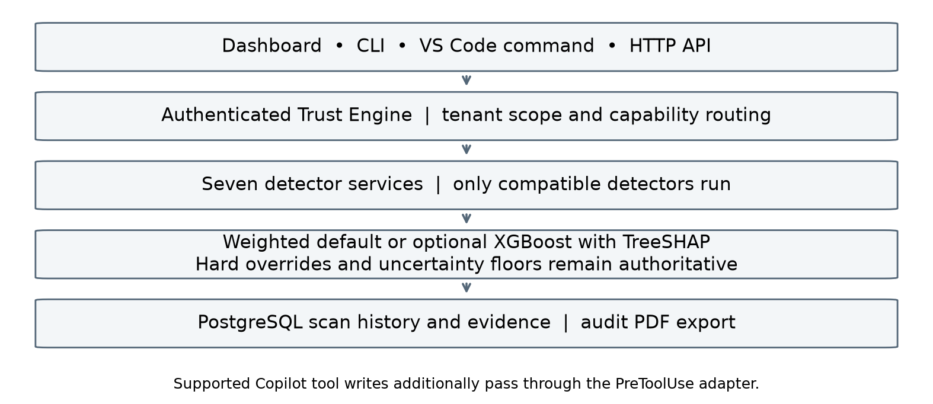
Figure 1.1. Overall structure of AI Supply Chain Guardian. Weighted scoring is the default; the trained model is optional.
The main points of the design are these.
• One result contract. All detectors emit an AgentResult with a status value set to one of six possible statuses (pass, warn, fail, error, stub, and pending). Two statuses, error and stub, have been introduced to allow a detector to declare that "I couldn't validate" or "this is not my file," respectively, without passing.
• A deterministic router. The routing table associates the artifact type with a set of detectors. Additionally, the router keeps track of a coverage value (full, partial, or none) for each file. Rule-based fusion. The calculation of the score starts from the initial value of 100 and takes off some points for each finding that exists, with the points deducted depending on the seriousness and certainty of the finding. The hard rules make it mandatory to issue a Reject decision in case of serious findings while other rules require that a Review must be done in case of partial coverage, a failure in the detector, a pending check, or in case of serious findings.
• Background checks. A slow check, such as the LLM judge for prompt injection or a container image lookup, can answer "pending". The scan is saved as provisional, and the final answer arrives later through a callback that must carry a separate secret.
• Tools for developers. The dashboard, the command line utility and the Visual Studio Code plugin use the same authenticated API.
• Measured results. The latest component-suite records contain 729 distinct Python passes in aggregate, not a single all-at-once run; nine distinct browser cases are counted separately. Research results include a 90-case development retest, an 18-case AI-labelled first-use pilot, ten project-team human-reviewed upstream files, earlier public prompt tests and actual Copilot execution evidence.
The work was split inside the team. The three authors and their areas are given in the work distribution table at the start of this report. In short, Abdulelah led the project and built CipherGuard, secret detection, Docker security, the trained scoring model and the VS Code extension. Ahmed designed the security schema and built code security, workflow security and artifact identification. Ali set up the development environment and built prompt injection, license compliance and the Trust Engine. Ahmed and Ali worked together on the LangGraph routing and its tests.

1.6 Relevance to the Sustainable Development Goals
The project relates to two Sustainable Development Goals. We describe this as a supporting relationship and not as a measured effect.
Table 1.2. Mapping to the Sustainable Development Goals
Goal | How the project relates
SDG 9: Industry, Innovation, and Infrastructure (United Nations, n.d.-a). | Software is one of the elements of the supporting infrastructure on top of which other systems can be built. Performing verification of the software artifacts before incorporating them into the project increases the reliability of the infrastructure as a whole. Core components are open source; optional hosted services have separate operating requirements.
SDG 16: Peace, Justice, and Strong Institutions (United Nations, n.d.-b). | Attacks on supply chains target organizations that benefit the public.A check that gives a clear reason for each decision, and refuses to hide missing checks, supports accountable and transparent handling of software risk.

1.7 Organisation of the report
The background and tools that are used in this research project are described in Chapter 2. Chapter 3 gives the requirements, the technology used, and the plan of work. Chapter 4 explains how the router, the fusion rules, the callback path, and the detectors were designed and implemented. Chapter 5 provides details on testing, results obtained, and problems that were found in our code. Chapter 6 gives the conclusions, the limitations, and possible directions of future work. The references follow in APA style. The appendices give sample requests and the commands for running the system and its tests.

Chapter 2

Literature Review
This chapter reviews the research that explains why the project is needed, and the tools and standards that we used or compared against. For each group we say what it means for our design.

2.1 Security of AI-generated code
Pearce et al. (2022) asked GitHub Copilot to complete 89 scenarios built from the MITRE list of common weaknesses, and produced 1,689 programs. About 40% of them were vulnerable. An early iteration of Copilot was used in the study; therefore, the exact number cannot be applied to the current applications. However, one thing is clear from the results: coding expertise does not always equal code security.
Perry et al. (2023) analyzed user interactions with an assistant. Participants with access to an AI assistant wrote less secure solutions than those without it, and they were more likely to believe their solution was secure. This is important for our design. If the developer trusts the assistant, then the process of checking for vulnerabilities should not depend on the skill of the developer in detecting these issues.
According to Schreiber and Tippe (2025), the vulnerability density differs depending on the programming language used. In particular, the density of vulnerabilities in Python is higher than in JavaScript and TypeScript. An earlier version of our code scanner used this result to lower the severity of JavaScript and TypeScript findings. The current scanner does not do this, because one study of public repositories is not a good reason to weaken a specific injection finding. Shukla et al. (2025) found that asking a model to improve code again and again can make its security worse. This supports checking every version of an artifact and not only the first.
What this means for the project: generated code needs an independent check, and the check has to run on the artifact itself, not on the developer's judgement.

2.2 Package hallucination and slopsquatting
Spracklen et al. (2025) report a large study of 576,000 generated code samples from 16 models, finding package hallucinations in both commercial and open-source model outputs. Repeated invented names create an opportunity for malicious registration. Krishna et al. (2025) examine how model, language and task specificity relate to hallucination behaviour. Zhao et al. (2025) introduce phrase-based fuzzing to uncover package hallucinations. These studies motivate registry checks but do not validate our detector accuracy.
In this case, the npm ecosystem analysis performed by Zimmermann et al. (2019) highlights the risks of a single malicious package. In this sense, as a single npm package is dependent on many other packages, a relatively small number of maintainer accounts is capable of affecting a large amount of the ecosystem. The fake name used becomes responsible for all this risk.
Implications for the project: the check has to read the dependency files themselves and confirm each package name against the official registry, and it should also look up known vulnerabilities for the versions it finds. CipherGuard does this for Python, npm, Rust and Go files, using the public registries and the Open Source Vulnerability (OSV) data format (Open Source Security Foundation, n.d.), as described in Section 4.7.3.

2.3 Prompt injection and guardrails
Greshake et al. (2023) described indirect prompt injection. The attacker does not talk to the model. These instructions will be embedded in the data which will later be interpreted by the model, such as websites, documents, or programming comments. According to the OWASP risk catalog, prompt injection is the primary risk associated with the use of LLMs (OWASP Foundation, 2025). In our setting the attacker target is a coding agent that later reads the repository.
Chennabasappa et al. (2025) describe layered guardrails for agents. Hackett et al. (2025) demonstrate evasion of prompt-injection and jailbreak detectors. These studies motivate layered screening but do not prove that our combination is superior. Guardian combines pattern rules, embedding similarity, a classifier and an optional judge; a failed judge remains unresolved rather than clean.
The embedding layer uses a small sentence-embedding model. Sentence-BERT (Reimers & Gurevych, 2019) illustrated the creation of sentence embeddings that can be compared using cosine similarity. MiniLM (Wang et al., 2020) exemplifies a small transformer which keeps most of its performance in a smaller size, while the publicly available checkpoint all-MiniLM-L6-v2 (Sentence Transformers, n.d.) serves as our loaded model.

2.4 Learned scores and their explanations
Fixed numerical weights are hand-selected. A trained regressor may fit labelled score anchors more closely. We evaluated constrained XGBoost for this purpose (Chen & Guestrin, 2016), imposing non-positive monotonic constraints on observed numeric risk features. This property is not proof that missing evidence, changed routing or new projects will be scored correctly.
A learned score is only useful in a security review if a person can see why it came out that way. SHAP (Lundberg & Lee, 2017) splits a prediction into one contribution per input feature, and for tree models the split can be computed exactly. We show these contributions next to the score. They explain the number the model produced. They do not explain the final decision when a safety rule overrides the model, and they do not show cause and effect.

2.5 Static analysis and the existing tool landscape
The first version of our detectors called mature open-source tools for most of the work. In the final version the default rules are our own, written on top of standard parsing libraries such as Python's ast module and Tree-sitter (Tree-sitter, n.d.). The older tools remain as optional adapters, which an operator can switch on. We changed this so that the system runs with fewer outside programs and so that every finding uses the same evidence format. Table 2.1 lists the tools and how each one is used now.
Table 2.1. Tools currently in use by the project or used as comparators
Area | Default in this project | Optional or external
Code security | Own rules on Python AST and Tree-sitter syntax trees | Semgrep, only when switched on
Docker security | Own Dockerfile and Compose rules; image inventory with advisory lookups | Hadolint and Trivy, only when switched on
License compliance | Registry SPDX data, own policy rules and matching against SPDX license texts | ScanCode as a fallback for license text
CipherGuard | Registry and version checks, name similarity, dependency graphs, OSV lookups | slopcheck, dep-hallucinator and two npm tools, compared by reading their source code only
Workflow security | Own YAML rules for GitHub Actions and GitLab CI | zizmor is the closest similar tool; not used
Prompt injection | Rules, decoded-text checks, MiniLM embeddings and a small classifier | An LLM judge through Groq or a local model
Trust Engine | FastAPI, LangGraph, fixed-weight scoring | XGBoost with SHAP, optional and not the default

The advice for secure usage of GitHub Actions is to pin third-party actions to a full commit SHA and to limit the permissions of workflow tokens (GitHub, n.d.). The advice from Docker on best practices includes the use of pinned base images, non-root users, and small images (Docker Inc., n.d.), whereas the NIST container security guide identifies the risks involved with images, registries, and orchestrators (Souppaya et al., 2017). Our Dockerfile and workflow rules follow these documents.
The categories of weaknesses included in our code guidelines are classified using Common Weakness Enumeration. The types that appear repeatedly in the automatically generated code are command injection (MITRE, n.d.-a), SQL injection (MITRE, n.d.-b), and hard-coded passwords (MITRE, n.d.-c).

2.6 Guidance and risk frameworks
NIST Secure Software Development Framework (Souppaya et al., 2022) stipulates conducting the software review and verification prior to the release process, including software bought from external organizations. Similarly, NIST Artificial Intelligence Risk Management Framework (National Institute of Standards and Technology, 2023) stresses the importance of assessing the risks that come with AI and the necessity of making decisions in an explainable way. Guardian is a relatively small software product that does not seek compliance with the frameworks mentioned above; however, the documents confirm the importance of review, justified by the rationale.

2.7 Comparison and research gap
Table 2.2. What existing approaches cover compared with this project
Capability | Single-purpose scanners | Guardrail libraries | AI Supply Chain Guardian
Code, Docker, workflow, dependency and secret checks behind one interface | No (one area each) | No | Yes (7 detectors, chosen per file)
Routes each file only to relevant checks | Not applicable | Not applicable | Yes (router with coverage value)
One score and decision with a stated reason | No (separate reports) | Per-prompt label | Yes (rule-based fusion)
Unknown result is never treated as clean | Depends on tool configuration | Depends on tool configuration | Yes (error, stub and pending states)
Slow checks without blocking the scan | Not applicable | Capabilities depend on the library | Yes (provisional result + protected callback)
History, audit report and editor use | Varies by tool | Usually not | Yes (SQL history, PDF, dashboard, CLI, VS Code)
Detection quality in its own area | Not measured in our comparative evaluation | Varies; can be evaded | Limited to our own rules; needs separate evaluation

The problem being addressed lies in the contradiction between the purpose-specific tool and the developer. A developer who accepts AI output needs one answer. The gap is not in the quality of any single detector. On that basis we cannot say that our detectors outperform those in Table 2.1. Not every detector runs on every file; each file only goes to the checks that fit it. We claim that this combination, with a safe way to handle unknown results, is useful, and we test those claims in Chapter 5.

Chapter 3

Software Requirements Specification

3.1 System overview and users
AI Supply Chain Guardian is a review service with its own user interfaces. The trust_engine service receives either a single or multiple files from the client. The result provided by the service includes the trust score between 0 and 100, decision whether to accept, review, or reject the content, a natural-language explanation, the coverage achieved, and the results returned by all detectors. The client could be the web interface, command line tool, VS Code extension, or any other software that uses the HTTP API.
There are three kinds of users.
• Developer: uploads the AI-generated text file using the dashboard, command prompt or the editor and gets the result together with the rationale.
• Reviewer/Team Leader: examines the rationale together with a review or reject decision.
• Detector maintainer: changes one detector service. This person needs the common result contract to stay stable, so that one change does not break the rest.
Scan submission, history and report retrieval require configured client API credentials. Tenant-scoped reads restrict access to the owning tenant; this does not imply application-level encryption. Callback credentials are separate and cannot be replaced by a client key. Health/readiness endpoints have a different operational purpose. These controls do not constitute a full public identity-management system.

3.2 Functional requirements
Table 3.1. Functional requirements and where they are met
ID | Requirement | Status
FR1 | Accept one file through POST /analyze or 1 to 50 files using names through POST /analyze/batch. File size restrictions apply to both individual files and batches. | Done
FR2 | Determine the type of artifact for each file based on the explicit type, the file path, or the file contents. | Done (router)
FR3 | Send each file only to the detectors listed for its type, and record coverage as full, partial or none. | Done (router + orchestration)
FR4 | Call detectors in parallel with a per-call time limit, a scan deadline and a concurrency limit. | Done (8 s per call, 9 s per scan, 12 calls)
FR5 | Each detector produces an AgentResult with status of pass, warn, fail, error, stub or pending. | Done (contract tests in each service)
FR6 | Combine all results into a score, a decision and an explanation. | Done (fusion)
FR7 | Never return Accept when coverage is incomplete, a detector failed, or a check is pending. | Done (caution floors)
FR8 | Force Reject for the four named detector overrides, for a detector that sets its decision floor to reject, and for a finding marked as a hard block. | Done (hard rejection rules)
FR9 | Support a slow check by returning a provisional result and later a final result. | Done (pending, callback, GET /scans/{id})
FR10 | Reject callbacks that do not carry the separate callback secret. | Done (X-Callback-Token)
FR11 | Detect hallucinated and look-alike package names in dependency files. | Done (CipherGuard)
FR12 | Detect insecure code patterns, hard-coded secrets, unsafe Dockerfiles and Compose files, unsafe workflows, license conflicts and prompt-injection text. | Done (six more detectors)
FR13 | Save scan history, findings, detector runs and scores in a SQL database. | Done (PostgreSQL or SQLite)
FR14 | Let an authenticated client list its own history and download an audit PDF for a scan. | Done
FR15 | Offer the review through a web dashboard, a command-line tool, a language server and a VS Code command. | Done
FR16 | Offer an optional trained scorer with explanations, without letting it override the safety rules. | Done (optional, not the default)

3.3 Non-functional requirements
Table 3.2. Non-functional requirements
Quality | Requirement | How it is met
Speed | The first answer should come back quickly; slow checks must not block it. | Slow checks finish in the background. An older benchmark is reported in Section 5.7 as a historical result, not a promise.
Safety | Unknown must not look like safe. | error, stub and pending states; Review floor.
Security | Clients, tenants and callbacks use separate credentials. | API keys per client and tenant; a separate callback token compared in constant time; private settings stay out of Git.
Isolation | A failure of a detector should not halt the scan. | Every detector is its own encapsulated unit; an erroneous decision becomes an error entry.
Explainability | Every decision has a rationale that can be explained by a human. | Explanation text contains the list of top risks and all rules fired; SHAP values if the model is used.
Determinism | The same evidence and settings give the same decision. | Fusion has no randomness. Live registry data and LLM answers can still change the evidence itself.
Cost | The system can run without paid services. | Core libraries are open source. Hosted models and deployment may incur costs; no audited cost total is asserted.
Maintainability | Detectors can be changed independently. | One shared schema, contract tests, and an additional step to ensure that the cloned contracts remain consistent.

3.4 Technology stack
Table 3.3. Technology stack
Layer | Technology | Purpose
Language | Python 3.12 service environments; Node.js and npm build toolchain | All services; dashboard and editor builds.
API and orchestration | FastAPI, Uvicorn, Pydantic, httpx, LangGraph | HTTP API, shared schemas, parallel detector calls and the route, call and fuse graph.
Code analysis | Python ast and Tree-sitter with our own rules | Code security detector; Semgrep only as an option.
Workflow analysis | PyYAML with our own rules | GitHub Actions and GitLab CI files.
Container analysis | Own Dockerfile and Compose rules; OCI image inventory; OSV data | Docker security detector; Hadolint and Trivy only as options.
Dependency and similarity | Registry APIs, OSV, jellyfish and RapidFuzz | Package checks and look-alike names.
Models | MiniLM embeddings, a classifier, an optional large language model (LLM) judge, XGBoost and SHAP | Prompt injection layers, and the optional trained scorer.
License data | Registry SPDX expressions and 708 pinned licence texts | License detection and license policy.
Storage | PostgreSQL database with SQLAlchemy and Alembic; SQLite for local development; Redis | Cache and evidence storage, Redis for caching and queues.
Interfaces | React and Vite dashboard, command-line interface, language server, Visual Studio Code (VS Code) extension, PDF report Exportation | Developer interfaces and audit export.
Packaging | Docker and Docker Compose | Eight microservices plus PostgreSQL, Redis, the migration process, and the dashboard.
Testing | pytest, Playwright, VS Code extension host | Testing services, browser tests, and editor tests.

3.5 Hardware, software and data requirements
Development and demonstrations used Windows and Linux. The latest 17–18 October checks used Linux, Docker services and recorded source/model hashes; the changed service suites used Python 3.12 environments. Browser and extension-host checks are recorded separately. Small serial loopback latency observations are not controlled hardware benchmarks or concurrent-load measurements.
Table 3.4. Environment needed to run the system
Item | Requirement
Processor and memory | Resource limits are configuration ceilings, not measured minimum requirements. Compose allows the prompt service up to 4 GB; size the host for the full stack.
Disk | Several gigabytes for the container images, the MiniLM model and the CPU version of PyTorch.
Software | Docker with Compose, and Git. Python 3.12 and Node 22 for running outside Docker.
Network | Needed to download models at build time. Package, license and vulnerability checks need access to the public registries and OSV. A hosted LLM judge needs its own API key.
Configuration | A private .env file in the repository root with the database password, the callback token and the client API key. Compose refuses to start without them.
Data | Evaluation uses 360 synthetic artifacts, a new 18-case AI pilot, ten human-labelled upstream files and an earlier public prompt dataset. Cohorts remain separate.

3.6 Security and deployment constraints
• The detectors are accessible via the Docker private network only. The trust_engine API is bound to the localhost (127.0.0.1), while the dashboard is connected to the API using its own proxy.
• PostgreSQL and Redis do not publish ports to the host. Redis host-port publication was removed after the earlier review; the Redis service still operates inside the private network.
• The database password, the callback token and the client keys come from a private .env file that Git ignores. The repository only contains .env.example.
• Live validation of found secrets is not done. It would need outbound calls to vendors, and a dead key in generated code is still a finding.
• The system does not execute the files it receives. It only reads them.
• The demonstration certificates for HTTPS are for localhost only. A public deployment would need a trusted certificate.

3.7 Use cases
Table 3.5. Main use cases
Use case | Steps | Result
UC1 Scan one generated file | Client posts the file. Router picks detectors. Detectors run. Fusion returns a decision. | Score, decision, explanation.
UC2 Scan several files | Client sends up to 50 named files to POST /analyze/batch. Each file is routed on its own. | One overall decision plus a result for each file.
UC3 Scan text with a borderline prompt-injection span | Detector returns pending. Client gets a provisional Review. Callback completes the scan. Client polls GET /scans/{id}. | Final decision after the LLM judge.
UC4 Scan an unknown file type | Router sends it to secret detection only and marks coverage partial. | Never Accept; at best Review.
UC5 Detector is down | The call times out or fails. The record is marked error. | Review with the failed detector named in the explanation.
UC6 Review history | Client lists its past scans and downloads the audit PDF of one scan. | Only scans of the same tenant are visible.

Figure 3.1 shows the actors and the use cases.
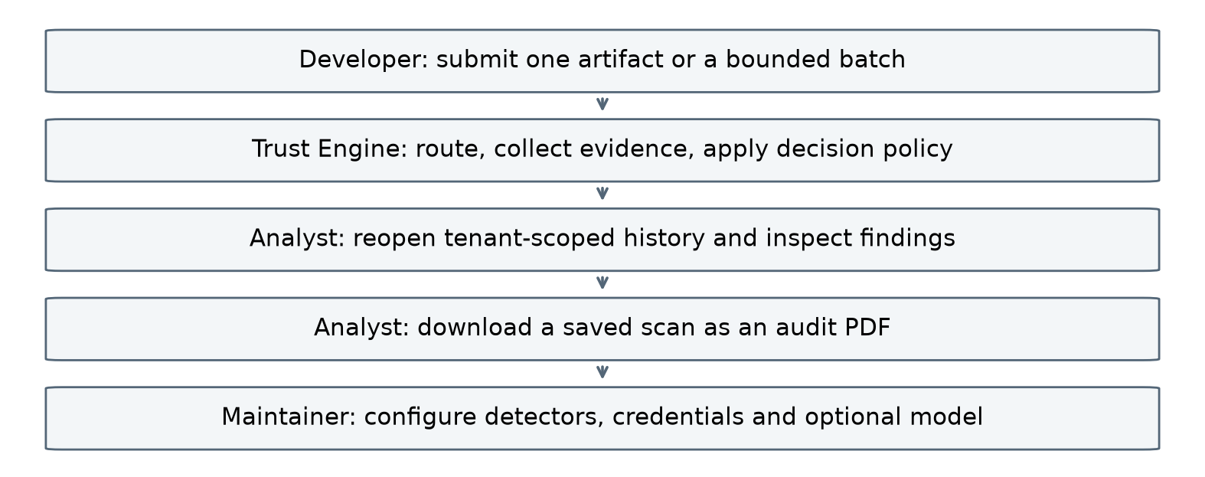
Figure 3.1. Actors and use cases.

3.8 Project plan and work distribution
The project ran from July to October 2026. Figure 3.2 summarizes recorded milestones through 18 October, including detector fixes, pinned image checks, model replay, supported Copilot pre-write execution and the submitted human review. This is recorded activity, not an approved planned-date baseline.
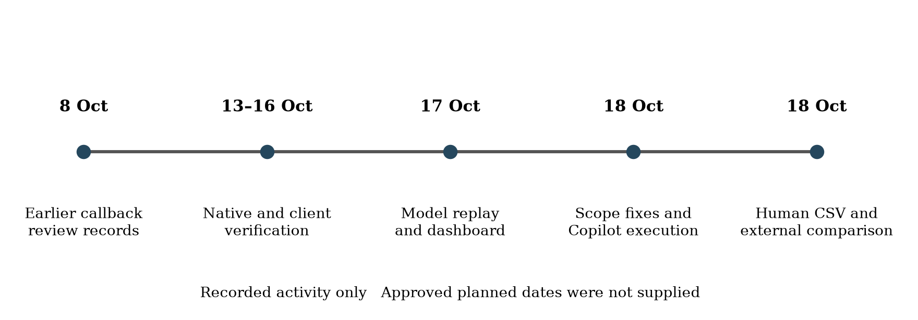
Figure 3.2. Recorded project milestones. No approved planned dates were available, so none are shown.
Table 3.6 shows who did what. All three members agreed on this table.
Table 3.6. Work distribution
Member | Main work
Abdulelah Alolofi (23070122009) | Project lead. Built the CipherGuard agent for package risk and typosquatting, the Secret Detection agent and the Docker Security agent. Added the trained trust scoring with SHAP explanations. Led the final integration and built the VS Code extension.
Ahmed Mohammed (23070122018) | Designed the project's security schema. Built the multi-language Code Security agent and the CI/CD Workflow Security agent. Added the preview and testing functions and artifact identification. Worked on LangGraph routing and its tests.
Ali Altam (23070122022) | Set up the development environment. Built the Prompt Injection Detection agent and the License Compliance agent. Designed the deterministic Trust Engine. Worked with Ahmed on LangGraph routing and its tests.

The table records the contributions agreed by the team. It does not give effort percentages.
The two callback pull requests in the first repository were written by one member and reviewed and merged by another. The review was done by running an attack against the code, which is described in Section 5.9.

3.9 Project cost
The project uses existing computing equipment, open-source core libraries and optional hosted or local AI services. No audited ledger or purchase receipts accompany the technical evidence, so a verified monetary total is not asserted. Existing equipment, electricity, network access, development effort and printing still consume resources even when no new invoice is recorded.
A deployment cost model is C_total = C_equipment + C_compute + C_model_API + C_storage_network + C_printing. Actual expenditure should be entered from the team ledger. Hosted judging, storage and compute may incur charges; the technical evaluation does not establish that these components cost zero.

Chapter 4

Design and Implementation

4.1 Architecture
The core application comprises seven detector services and trust_engine. This separation supports independent service maintenance and bounded handling of detector failures. PostgreSQL, Redis, migrations and the dashboard are supporting deployment components; therefore eight application services must not be described as eight containers in total.
The services talk to each other over HTTP on the Docker Compose network, by service name. The detectors have no public port. The trust_engine API is confined to the local machine, while the dashboard accesses the API using its own proxy server that exists on the same origin. Compose, in addition, starts PostgreSQL, Redis, and runs the single-use migration job to create database tables. PostgreSQL holds the scan history. Redis is used for caches and for pending work, but it is not the record of a scan.
Figure 1.1 summarizes the architecture and Figure 4.9 the supported pre-write gate. The lifecycle of an individual scan is described below.
1. The client (dashboard, command-line, VS Code, or the API) submits either one file at POST /analyze or in batches at POST /analyze/batch along with their API key.
2. trust_engine validates the API key and size restrictions and determines the artifact type and detector list per file at the route step.
3. The call_agents function runs the chosen detectors in parallel within a time frame.
4. The fuse function uses the safety rules and the scorer to get the score, the decision, and an explanation.
5. This is then stored in storage with secret values hidden. If the detector had answered "pending," the stored scan was just provisional, and the client gets the definitive result at GET /scans/{id}.

4.2 Shared result contract
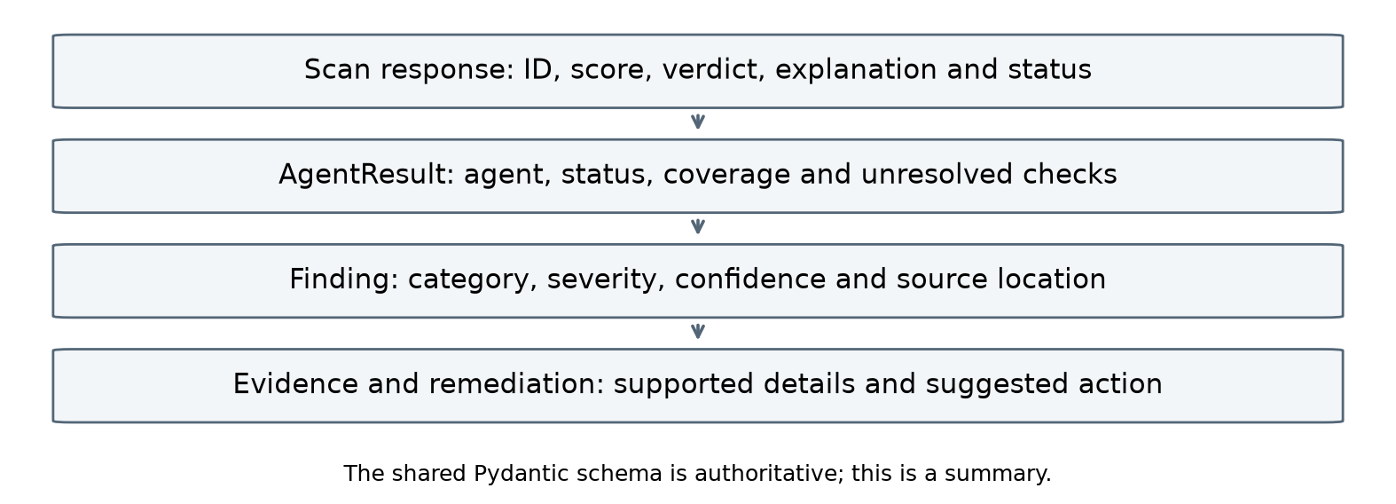
Figure 4.1. Result layers and evidence fields. This is just a summary, the Pydantic classes used in the code contain a full definition.
AgentResult includes coverage, unresolved and decision_floor alongside its status and findings. Coverage describes the requested check scope, not proof of complete program security. The unresolved flag exposes incomplete evidence; a detector floor can require Review or Reject. Individual findings can carry hard_block. Error or pending results cannot retain a clean Accept floor.
The status field has six values. The first three describe what a detector found. The last three were added so that a detector can describe what it could not do.
Table 4.1. Meaning of the six status values
Status | Meaning | How fusion treats it
pass | The detector ran and found nothing. | Counts as clean, but only together with its coverage.
warn | The detector ran and found something that is not severe. | Findings reduce the score.
fail | The detector ran and found a high or critical issue. | Findings reduce the score; the severity floor applies.
error | The detector did not finish (timeout, crash, bad reply, failed judge). | Unknown, never clean. Decision is at least Review.
stub | The artifact type is not supported by this detector. | No opinion and no weight. Shown in the explanation.
pending | The answer will arrive later through the callback. | Decision is at least Review and marked provisional.

The absence of results does not mean the absence of problems. An analyzer that was not launched could not detect the file. Early in the project, a detector that crashed returned fail, and an unsupported file type could return pass. Both were wrong in different ways. The schema audit (Section 5.3) and the later fixes made the six-value status the same in all seven detectors, and the coverage and unresolved fields now make the same point inside every result.

4.3 Artifact router
Router is defined in routing.py file and is described as pure function. In case of one file, it returns a RoutingDecision object that includes artifact type, how the type has been found (routing_source), expected list of detectors (expected_agents), coverage measure, and some comments. Since the method does not make any network calls and does not use any models, testing this function becomes extremely simple, and one can be certain that an equal input will always yield an equal output. All possible types, files, and file extensions are listed in one file named capabilities.json.

4.3.1 Type resolution order
Type determination follows this order and takes the first successful match.
1. Explicit: Client provided a type. If it is not one of the known eight types (code, dockerfile, compose, workflow, dependency, markdown, license, unknown), then API will return an HTTP 422 error. Router will not speculate around an erroneous explicit value. If filename hints at another type, it is still overridden by the explicit value; however, a note is added, and coverage becomes partial.
2. Path rules: .yml file in .github/workflows/ or .gitlab-ci.yml file is workflow; Dockerfile and Containerfile are dockerfile; docker-compose.yml and compose.yaml are compose file; LICENSE and COPYING are license text; .md file is Markdown and requirements files, package.json, package-lock.json, pyproject.toml, Pipfile, Cargo.toml, Cargo.lock, go.mod, go.sum, poetry.lock and uv.lock are dependency files. Extensions of the programming languages such as .py, .js, .ts, .jsx, .tsx, .mjs, .cjs, .php, .java, and .go are code.
3. Content sniffing: only used in the absence of a filename in the client’s input.
4. Fallback: the type is unknown.
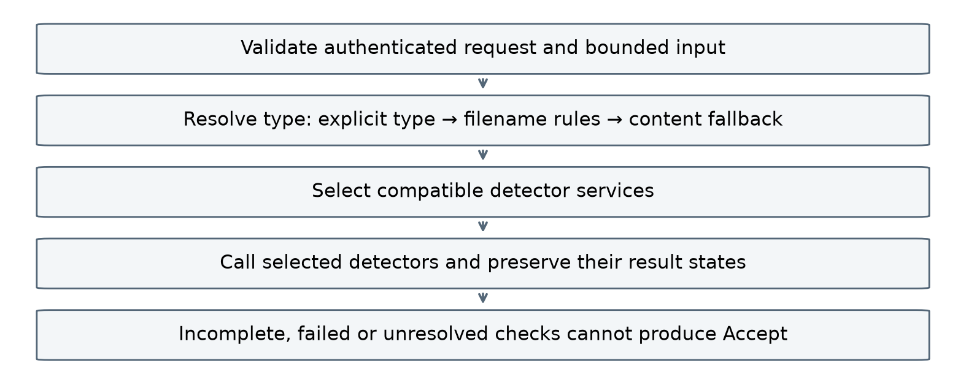
Figure 4.2. Request validation, type resolution, detector selection and handling of incomplete checks.

4.3.2 Routing table and coverage
Table 4.2. Routing table
Artifact type | Detectors that run | Coverage
code | code_security, secret_detection, prompt_injection | full
dockerfile | docker_security, secret_detection | full
compose | docker_security, secret_detection | full
workflow | workflow_cicd, secret_detection | full
dependency | cipherguard, license_compliance, secret_detection | full
markdown | prompt_injection, secret_detection | full
license | license_compliance, secret_detection | full
unknown | secret_detection only | partial
binary file larger than 1,000,000 bytes or unsupported lockfile | none | none

Secret detection works for all possible formats since the secret could be inside of source code, a Dockerfile, ENV field, a workflow variable, and even inside of a README file. Prompt injection works on both code and Markdown since they consist of free text that could be later picked up by an AI agent.
In the first version, every lockfile was ignored. Currently, the following lockfiles are being passed as dependency files since CipherGuard can understand them. Lock files it doesn’t recognize yet, such as yarn.lock, pnpm-lock.yaml, and composer.lock, are still not sent to anyone, since the lengthy hash strings inside would simply generate many false positives of secrets found. The routing process does not equal full dependency graph resolution; if it was not resolved, then partial coverage is reported.
The router itself does not accept any content larger than 1,000,000 bytes. This is an internal safety guard. The public API applies much smaller limits before the router is reached: 256 KiB per file, at most 50 files in a batch and 1 MiB for the whole batch. The coverage of a whole request is the worst coverage across its files, and an empty request has coverage none.

4.4 Orchestration
The LangGraph graph has three nodes: route, call_agents and fuse. The state that moves through them is a GraphState. Results processing uses a reducer (operator.add), thus enabling parallel invocation of detectors to add a single AgentCallRecord for each call without interfering with each other. For every combination of file and detector, AgentCallRecord is generated, whether there is a successful call or not. This structure stores details such as the expectation of the detector, the execution of the agent (agent_ran), its status, result, duration in milliseconds, cause of error and callback id. The records are what fusion reads.
Several limits protect the detectors and the server. They are listed in Table 4.3.
Table 4.3. Orchestration limits
Control | Value | Why
Single file at POST /analyze | 256 KiB | Rejects large uploads before any work starts.
Batch at POST /analyze/batch | 1 to 50 named files; 256 KiB each; 1 MiB in total | Checked by the request model before routing. Bad batches are refused, not cut short.
Guard router size | 1,000,000 bytes | It’s an internal guard; the external limits are less.
MAX_CONCURRENT_AGENT_CALLS | 12 calls per scan | A semaphore is used to ensure that only a certain number of detector calls run simultaneously.
GLOBAL_AGENT_WORKERS | 12 by default | Limits detector calls across all scans on the server; can be changed in the settings.
Detector timeout | 8 s by default | A slow detector is marked as error. Each detector can have a shorter limit.
Scan deadline | 9 s by default | The first answer has to be ready by then. This is not a limit on background checks.

When a detector fails or runs out of time, its record stays in the result with status error and a reason. It is never removed, so the explanation can name the check that is missing.

4.5 Fusion
Fusion is a pure function; it doesn’t make any HTTP calls, doesn’t access the database, doesn’t depend on the time, and contains no random elements. For the same GraphState and settings, it will produce exactly the same output; therefore, it may be run again once a callback arrives. The safety rules are fixed and readable. The number in the middle can come from fixed weights, which is the default, or from the optional trained model described in Section 4.5.4.

4.5.1 The score
Each finding costs points. The cost is the severity weight times the confidence of the finding. The score will be equal to 100 minus the total cost, which stays within the range from 0 to 100.
risk(findings) = weight[severity] * confidence
trust_score = clamp(100 - risk_total, 0, 100)
weight = critical 40 | high 25 | medium 10 | low 3 | info 0

4.5.2 Hard rejection rules
Six situations force Reject, whatever the score is. When one of them fires, trust_score is reported as 0.0 and the trained model is not asked at all, because a score of 92 next to the word "reject" would mislead a reader. The per-detector contributions are still reported so that the reader can see what else was found.
Table 4.4. Hard rejection rules
Rule | Condition
CipherGuard score of 90 or more | A package reached the override threshold (a package that does not exist scores 100).
Confident secret | A critical secret, or a high secret with confidence of 0.85 or more.
Critical prompt injection | A critical prompt-injection finding.
Critical code security | A critical code-security finding.
Detector rejection | A finished detector result has decision_floor set to reject.
Hard block | A finished detector finding has hard_block set to true.

4.5.3 Caution floors and decision bands
After the score is computed, the decision is taken from the bands: 80 or more is Accept, 50 to 79 is Review and below 50 is Reject. Then the caution floors are applied. A floor can only make the decision more cautious. It never moves a decision toward Accept.
• Coverage floor: partial or no coverage floors the decision at Review.
• Status floor: any expected detector with status error, any unresolved result or any pending result floors the decision at Review. A pending result also marks the explanation as PROVISIONAL.
• Detector floor: a detector can set its own decision_floor to review.
• Severity floor: any high or critical finding floors the decision at Review. Without it, a high finding with a lower confidence (0.7 costs 17.5 points) would leave the score at 82.5 and give Accept.
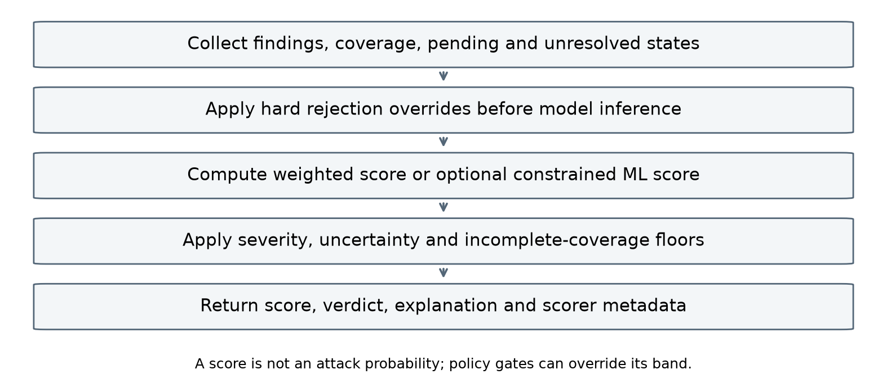
Figure 4.3. Order of evaluation in the fusion step. The numeric score stays below the safety rules.
The explanation is a text string built from the same facts. It states the score and decision, the top risks with their file and location, and every rule that moved the decision. A reviewer can therefore see why a file was held at Review without reading the code.

4.5.4 The optional trained scorer
TRUST_SCORER selects weighted scoring by default. Explicit ML mode converts detector evidence into 98 risk features and uses a constrained XGBoost regressor to estimate a 0–100 trust score (Chen & Guestrin, 2016). Non-positive monotonic constraints apply to observed numeric risk features; they do not prove generalization across missing values, changed routing or new artifact families. Exact TreeSHAP decomposes the raw model prediction into additive contributions (Lundberg & Lee, 2017).
Hard rejection rules bypass the model. The native model file, metadata, feature order and checksum are validated before inference. An unavailable or invalid model produces an explicit weighted fallback and at least Review. Policy floors remain authoritative after ordinary model scoring. SHAP explains the numerical prediction before policy gates, not causality or attack probability. Training uses synthetic labels; the later human-labelled evaluation reveals weak external agreement, so the candidate remains unpromoted.

4.5.5 Worked example
Consider a file in Python which has a single finding with severity as high at 0.85 with no other findings, say evaluation of user inputs. Cost would be 25 x 0.85 = 21.25, thus score would be 78.75. That falls in the Review band, and the severity floor would also hold it at Review. This is exactly the result we saw in VS Code (Section 5.8). An earlier version of the code scanner downgraded high vulnerabilities in JavaScript and TypeScript to medium, which made the exact same vulnerability an Accept at 91.5. The current scanner does not do this, so a high finding gives Review in every language.

4.6 Background checks and callback security

4.6.1 Why some checks are asynchronous
Some checks are too slow for the first answer. The prompt-injection detector can ask an LLM to judge a borderline text span, which takes seconds and can fail. The Docker detector can look up the packages inside a container image, which needs several network calls. So these detectors answer in one of two ways. If they are sure, they answer at once. If not, they return status pending with a callback_id and finish the work in the background.

4.6.2 The flow
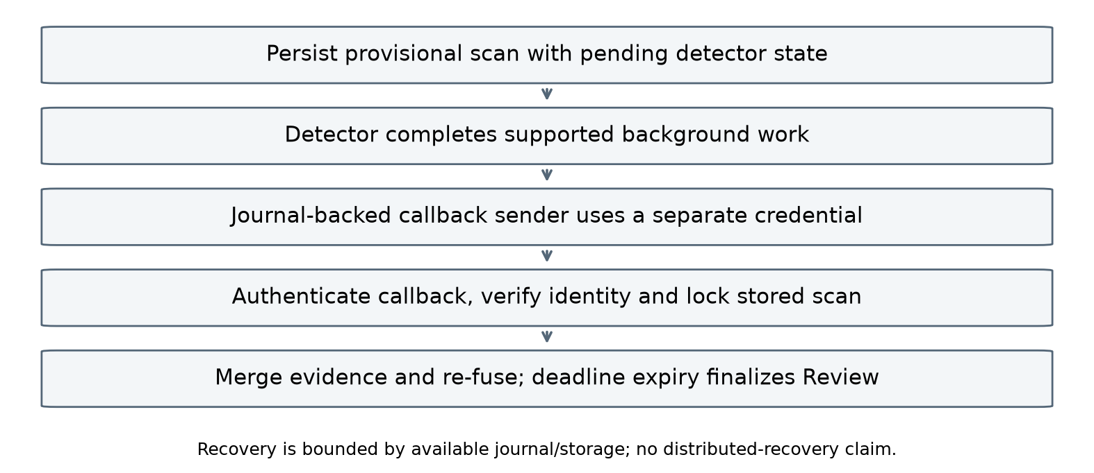
Figure 4.4. Background resolution and the authenticated callback.
1. trust_engine calls the selected detectors. One of them replies with status pending and a callback_id.
2. trust_engine fuses what it has. The result is provisional and at least Review. It gets saved in the database directly, and is returned to the client.
3. The detector completes its background task and uses a journal-backed callback outbox. Retry/recovery depends on retaining that journal and its configured storage; it is not a guarantee against every container or disk failure.
4. The detector sends the AgentResult to POST /callback/{callback_id} using the header X-Callback-Token.
5. The trust_engine will validate the token and body and find the scan owning this callback id, lock the scan, add the new result and perform fusion over all the evidence.
6. The client requests for GET /scans/{request_id}. The scan_status becomes final when there are no more callbacks.
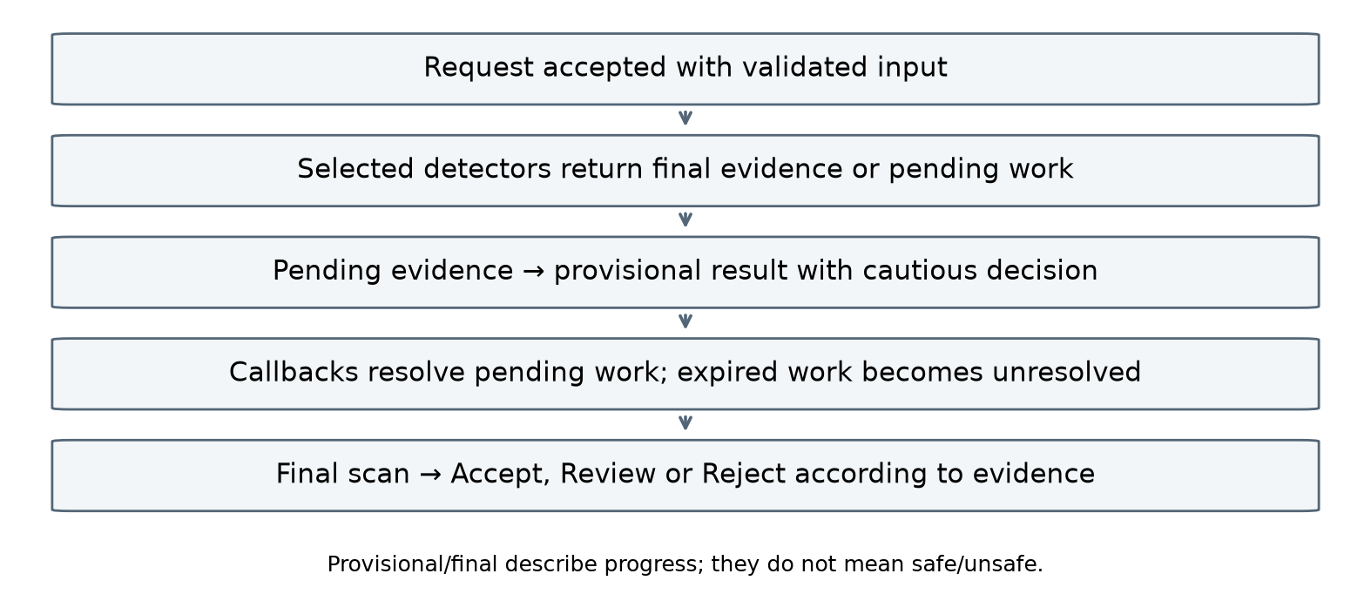
Figure 4.5. States of a scan. Provisional and final describe progress, not whether the file is safe.
A pending check cannot stay open for ever. If no callback arrives within the pending time limit (180 seconds by default), trust_engine marks that check as error with the reason "pending callback deadline exceeded" and finalises the scan. The decision then stays at least Review, because the check never finished.

4.6.3 Callback security
The first version of the callback endpoint, in the earlier repository, had no authentication. During review, this was tested as an attack and it worked. A forged callback with status pass was accepted and changed the recommendation of a file from Review to Accept. The details are in Section 5.9. The fix is still in place, and the current handler adds more checks.
• Callbacks must carry X-Callback-Token, checked with hmac.compare_digest to reduce token-comparison timing leakage. This does not guarantee that the complete HTTP handler takes identical time for every request.
• The token is checked before anything else, so an attacker cannot learn which callback ids exist.
• If no token is configured, the endpoint returns 503 and does nothing else. A wrong or missing token gives 401. Docker Compose refuses to start without CALLBACK_TOKEN.
• The callback token is different from the client API keys, so a client cannot finish its own pending scan.
• The body must be a valid AgentResult. A callback id that does not match, or a callback that still says pending, is refused with 422. A callback for work that is already finished gets the answer already_resolved and changes nothing.

4.6.4 Locking and the callback race
Updates occur inside store.locked(request_id), using a PostgreSQL row lock or SQLite write transaction. Conflicts have bounded retries and may return 409. A provisional scan is persisted before the client response, while detector outbox retries handle callbacks that reach the API before their scan is retrievable. These mechanisms reduce race-related loss; they are not a proof of arbitrary distributed failure tolerance.

4.6.5 Failed judge
One more issue was found in the way the detector treated a failed LLM call. If the judge timed out or the API key was wrong, the span was treated as "not an injection", and the file could be accepted. A failed judge means we do not know. The detector now returns status error in that case, and fusion floors it at Review. Disagreement between the judge and the other layers is also not counted as clean.

4.7 Detector services
The following sections describe the seven implemented detectors, their default engines and their boundaries. Their regression suites test specified behaviour; separate cohort evaluations measure agreement with labelled cases.

4.7.1 Code security
The default engine parses the code instead of searching the text. Python is read with the standard ast module, and JavaScript, TypeScript, PHP, Java and Go are read with Tree-sitter syntax trees (Tree-sitter, n.d.). Our own rules then look for the mistakes that AI assistants make often: building an SQL query by joining strings, passing user input to a shell command, calling eval on input, unsafe deserialisation, switching off TLS verification and careless handling of passwords and keys, among others. The engine follows simple assignments and renamed imports inside one function, so renaming os.system does not hide it.
Each finding includes a category, severity, confidence, location and available remediation. Python evidence identifies guardian_python_ast and whether parsing was partial. Analysis is intraprocedural, not whole-program proof. The 18 October fix recognizes password-like function context even when its parameter has a generic name, with checksum negative controls. Semgrep remains an optional compatibility engine; 37 rules refers only to the historical engine.
Status rule definition is as follows: no finding – pass; high or critical finding – fail; any finding with a severity less than high – warn. A file that is not code gets stub. If parsing or the engine fails, the service returns error, and a file that could only be parsed in part is marked as partial coverage. The first version returned fail for a crash, which meant two different things, "found a serious bug" and "could not check", shared the same value. This was changed after the schema audit.

4.7.2 Workflow and CI/CD security
The workflow detector parses the YAML file instead of searching the text, with a size limit on what it will read. One detail matters here: a YAML parser reads the key on as the boolean value True, so the loader normalises the input first, and a small line finder maps each result back to the original line. The detector comprehends both GitHub Actions and GitLab CI files.
Table 4.5. Workflow checks
Check | What it looks for
Unpinned actions | A uses: reference with no ref, a branch ref, or a tag instead of a full commit SHA. Local actions (./path) are skipped.
Permissions on risky triggers | Triggers such as pull_request_target or workflow_run, which run with repository secrets on content from outside contributors, combined with a missing permissions block, write-all or broad write access.
Execution of remote scripts | Piping curl or wget into a shell, or Invoke-WebRequest into Invoke-Expression, in a run step or a GitLab script.
GitLab CI rules | Risky script lines and settings in .gitlab-ci.yml jobs.

The detector also reports a workflow risk score from 0 to 100, as extra information for the reader; fusion uses the findings, not this number. A file that is not a workflow returns stub, and a file that cannot be parsed is reported as unresolved instead of clean. Workflows that include files from other repositories, and reusable workflows defined elsewhere, cannot be fully followed, so those parts stay partial.

4.7.3 CipherGuard
CipherGuard scans the compatible dependency files such as requirements.txt file, package.json and package-lock.json for npm, pyproject.toml, Pipfile, poetry.lock and uv.lock for Python, Cargo files for Rust and go.mod and go.sum for Go language. It queries the registry to check whether the names and versions provided for each of the packages are valid and also checks whether the name is similar to any of the well-known packages, finds the dependency graph and queries OSV (Open Source Security Foundation, n.d.) to find the vulnerabilities of the resolved versions. Registry answers are cached.
The score for a package is based on a similar logic to the first scoring system. An unknown name in the registry receives 100 points. The existence of a package means points due to certain signals such as a probable typosquat, a recently created package, having a single maintainer or having few downloads, but still the package cannot achieve a score of 90 through this method. This way, heuristics cannot block a legitimate package by themselves.
At most 100 registry checks are admitted per artifact; unchecked packages make coverage partial. npm and Python expose richer similarity and maturity data than the bounded Rust and Go paths. Go licence evidence may remain unknown. Package existence is not a security guarantee. As of 18 October, direct network-to-shell pipelines in package install lifecycle scripts are hard-blocked even when dependencies is empty; this bounded static rule is not a complete shell interpreter.
The team also read the source code of four open-source slopsquatting tools and compared the design with CipherGuard (CODE_COMPARISON.md in the repository). This is an interpretation of their algorithm, not a test of the same inputs. The main details are shown in Table 4.6.
Table 4.6. Code-level comparison of slopsquatting tools (from the repository)
Tool | Size | Finding from the source code
slopcheck | approximately 1,760 lines | Compares package names against a static list of 37 PyPI packages that could create a false positive if the package name resembles one of the listed packages.
dep-hallucinator | approximately 12,581 lines | Has a file called ml_engine.py but no machine learning algorithm implemented.
matt-slopcheck | about 916 lines | Only checks existence. No similarity check.
slopguard | about 913 lines | Only checks existence, as a Claude Code hook. No similarity check.
CipherGuard (first version) | about 674 lines | Existence check, normalised edit distance against a large popular-package snapshot, and metadata signals.

4.7.4 Secret detection
Secret detection is rule-based, not machine learning, because the problem is pattern matching with fixed vendor formats. It works in layers. The first layer works with the vendor formats, like AWS keys, GitHub tokens, Stripe, OpenAI, Slack and Google keys, npm and PyPI tokens, Azure connection strings, JWTs and private keys. The subsequent layers examine structure, such as an assignment to the variable named password or token, measure the randomness of the value and filter out known examples and placeholders. The last layer sets the confidence and writes the reason. Secrets are masked in everything the service returns.
Keys are not validated by sending them to vendors. A revoked or example credential can still require review under the configured policy. Known formats and context rules are finite and may produce misses or false positives. Redaction reduces disclosure in returned evidence, but retention, storage paths and exported files must also be handled deliberately.

4.7.5 Docker security
Docker detector scans Dockerfiles and Compose files by our custom rules for the issues like running as root, unpinned base images, privileged containers, and Docker socket being mounted. For a supported base image, it can also start a background job that downloads the image metadata and layers, lists the operating-system packages inside and looks them up in vulnerability data. This works today for public Docker Hub images for linux/amd64 that are based on Alpine (APK) or Debian (DPKG). Language packages inside the image need a separate scan of their lockfiles.
The detector can suggest a harder Dockerfile; the suggestions themselves are not built or runtime-tested. Supplied-text scope evaluates the submitted configuration only. Resolved-image scope additionally inventories supported pinned images and checks OS-package advisories. Normal container requests retain resolved-image checks by default. Bounded transport retries improve transient-failure handling. Four digest-pinned Alpine, Debian, Python and Node inventory fixtures completed in the latest operational check; CVE correctness was not independently adjudicated. Hadolint and Trivy remain optional.

4.7.6 License compliance
The detector reads the same dependency files as CipherGuard. It then retrieves the licence from the registry for each package, with preference for the SPDX expression and then evaluates it based on the policy. If the input is a LICENSE or COPYING file, it will compare it with a pinned set of 708 SPDX licences. If a licence is unknown, changed or unclear, the package is marked for review with a reason. ScanCode may still be employed as an alternative fallback to provide the licence text. Being familiar with the licence of every package does not ensure legal compatibility of the entire project.

4.7.7 Prompt injection
The detector searches for any hidden commands within comments, docstrings, strings, and Markdown text. The process begins by extracting the text spans. Pattern matching is applied on the text and its transformed versions like removal of spaces, ROT13 encoding, hexadecimal, and base64. Furthermore, zero width characters and similar looking characters from other languages are also searched for. Subsequently, the span is compared against attack sentences using MiniLM embeddings, and finally, a small classifier confirms the same. Spans that are still uncertain go to an LLM judge in the background. A final pass checks weak spans together, in case an attack was split across several comments.
A hosted or local model may judge uncertain spans. Earlier recorded public tests used Groq with openai/gpt-oss-20b. A failed or unresolved judge never counts as clean. The Markdown authority-precedence case is now blocked, but benign documentation and source comments still generate uncertainty and excess Review outcomes. Public-test misses and the human-reviewed upstream results prevent any claim of general prompt-injection protection.

4.8 Persistence and database design
SQLAlchemy models and Alembic migrations support persistence. Docker Compose uses PostgreSQL; a local launch may use SQLite. The API writes tenant-scoped snapshots and normalized scan data transactionally. Figure 4.6 summarizes the main relationships.
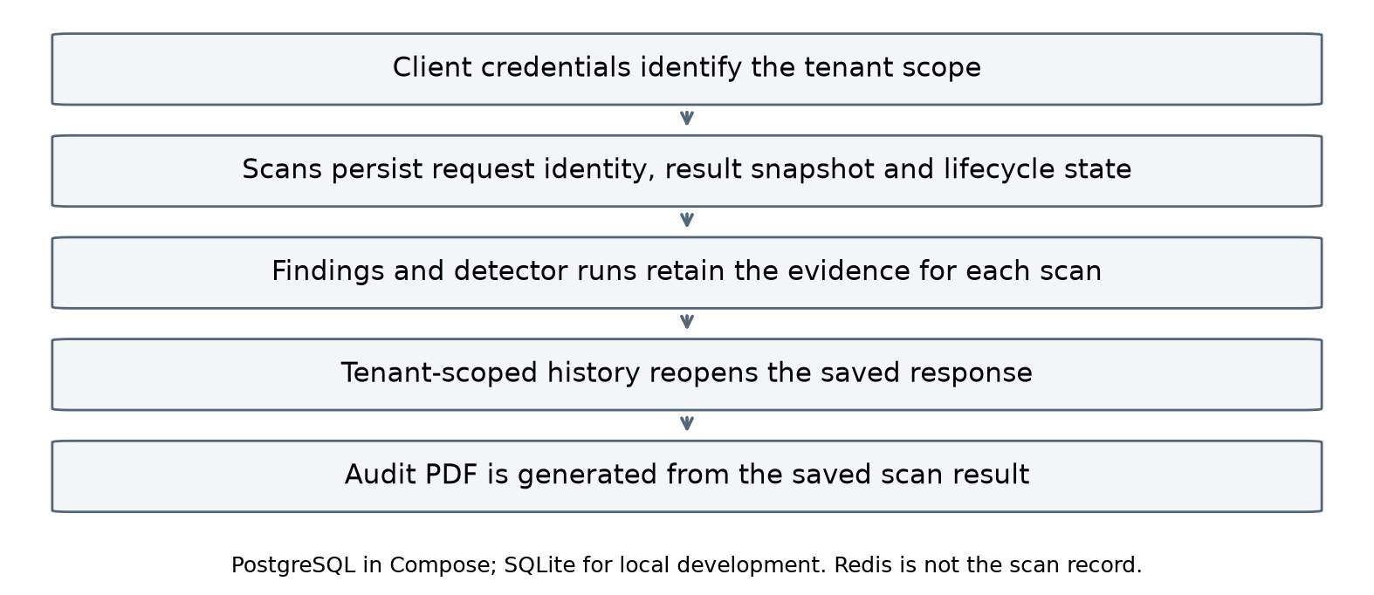
Figure 4.6. Main database relationships and tenant scope.
An artifact can have many scans. A scan has many findings and many detector execution records, and one trust score. A ScanSnapshot stores the full saved state of a request together with its tenant, and trust_engine writes the snapshot and the related rows in one transaction. History and single-scan reads always filter by tenant. The old final scans are deleted after a certain retention period, which by default lasts 30 days. Redis is used for caches and pending work, although it does not serve as a record of the scan.
The schema also defines detail tables for dependencies, secrets and Docker findings. These fields exist within the database, but the current write path does not populate all of them, and therefore, their mere existence cannot be taken to prove that these details are stored.

4.9 Deployment
Docker Compose defines the eight application services plus PostgreSQL, Redis, migrations and the dashboard. Each service has a Dockerfile and requirements; Compose injects the environment variables needed by that service rather than mounting one private configuration file into every service. POSTGRES_PASSWORD, CALLBACK_TOKEN and GUARDIAN_API_KEY are required operator settings. Detectors send authenticated callbacks through the internal trust_engine service address.
copy .env.example .env # Set POSTGRES_PASSWORD, CALLBACK_TOKEN, GUARDIAN_API_KEY
docker compose up --build -d
# Dashboard: http://localhost:3000 API Docs: http://localhost:8000/docs
The second compose file adds HTTPS to the dashboard using a localhost certificate. The localhost certificate is used only for demos. A production-ready deployment will require a trusted certificate, as well as backup and load testing.

4.10 API and data flow
Table 4.7. Public endpoints of trust_engine
Method and path | Purpose
POST /analyze | Use one artifact with an API key; UTF-8 encoded content not more than 256 KiB.
POST /analyze/batch | Use 1 to 50 artifacts in the name, under the file and total size constraints
GET /scans | Returns pages of scans history for the tenant calling the API.
GET /scans/{request_id} | GET Returns one scan of the same tenant from the history; either provisional or definitive.
GET /scans/{request_id}/audit.pdf | GET Downloads PDF report for the specified scan.
POST /callback/{callback_id} | Internal; used by detectors with the unique callback token.
GET /health | Reports whether the service and its dependencies are ready; not a security check.

Figure 4.7 shows the activity of one scan request from the client to the saved result.
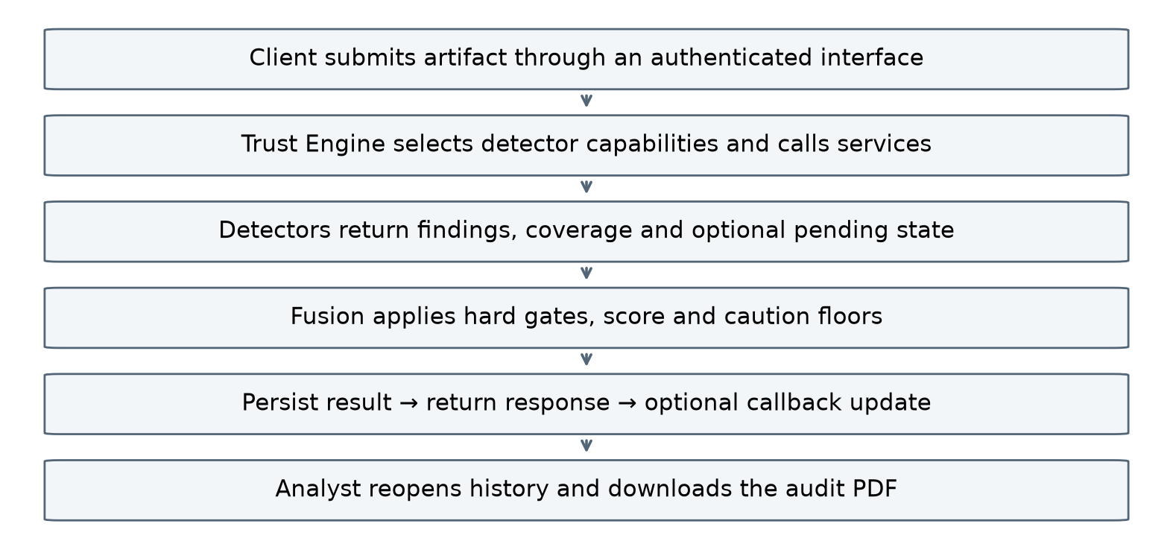
Figure 4.7. Activity of one scan request, from the client to the saved result.
Figure 4.8 is the data flow. Data flows from the authorised client to trust_engine and then to the chosen detectors. If necessary, the detectors retrieve the data from the package registries, vulnerability feeds, license data or LLM judge. Fusion consumes the evidence and saves the masked results and sends the client the decision. The clients consume history and PDFs later, and callbacks update the saved request.
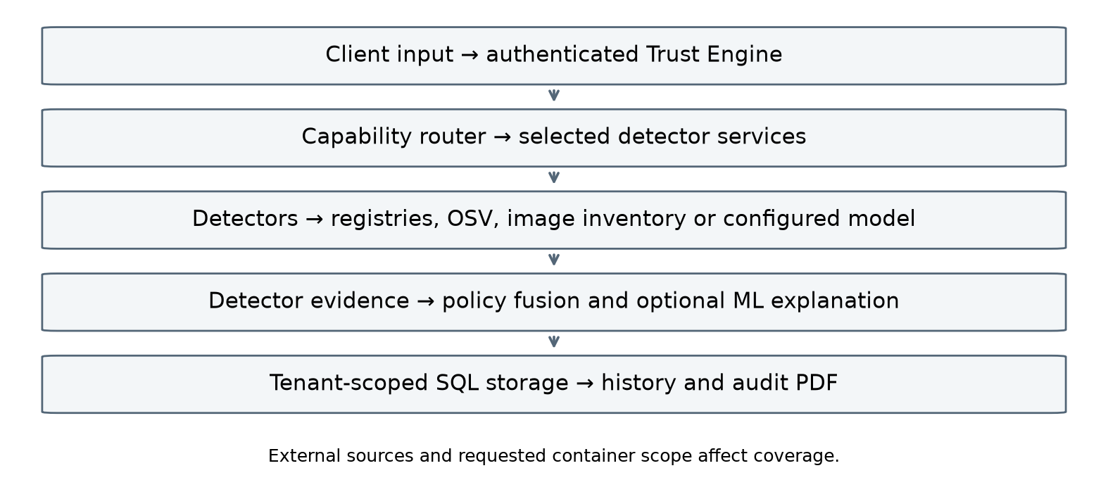
Figure 4.8. Data flow using tenant-scoped storage and protected background updates.

4.11 Implementation excerpts
The following excerpts are explanatory pseudocode condensed from the implementation. They omit validation branches and are not intended to be pasted as complete executable functions. Full source files remain the implementation authority.

4.11.1 Router: guards and explicit type
The router rejects binary or oversized internal input before type resolution. Its internal 1,000,000-byte guard is distinct from the public per-file limit of 256 KiB. Explicit types are validated before filename or content inference.
# Explanatory pseudocode
route_file(content, filename, explicit_type):
if binary(content) or bytes(content) > internal_limit:
return no_agents_with_none_coverage
if explicit_type is supplied:
validate_type_or_raise_422(explicit_type)
return route_explicit_type_with_conflict_notes
if filename is supplied:
return route_using_filename_rules
return route_using_content_or_unknown

4.11.2 Callback: authenticate, then lock
_check_callback_token(request) # 401 or 503 before anything else
body = AgentResult(**(await request.json())) # invalid body -> 422
rid = await store.request_id_for_callback(callback_id)
async with store.locked(rid) as stored:
timed_out = finalize_overdue(stored) # close checks that waited too long
changed = apply_callback(stored, callback_id, body)
# shortened: id mismatch, 404, retry on conflict and the reply are left out
Authentication precedes callback identity lookup. The stored update is performed under the selected database lock or transaction semantics. The separately completed scratch PostgreSQL test verifies persistence read by a second store and serialisation of two concurrent callback updates; it is not a forced database-server restart or distributed stress test.

4.11.3 Fusion: rules first, then the number
# Explanatory pseudocode
derive coverage and unresolved checks
if hard_reject(evidence): return 0, Reject
score = configured_scorer_or_weighted_fallback(evidence)
verdict = band(score)
verdict = apply_caution_floors(verdict, evidence)
return score, verdict, explanation, scoring_metadata

The helper who puts the floors into effect follows the safer of the two decisions. The sequence is approve, examine, reject, so a floor is capable of taking a decision up but not down the sequence.
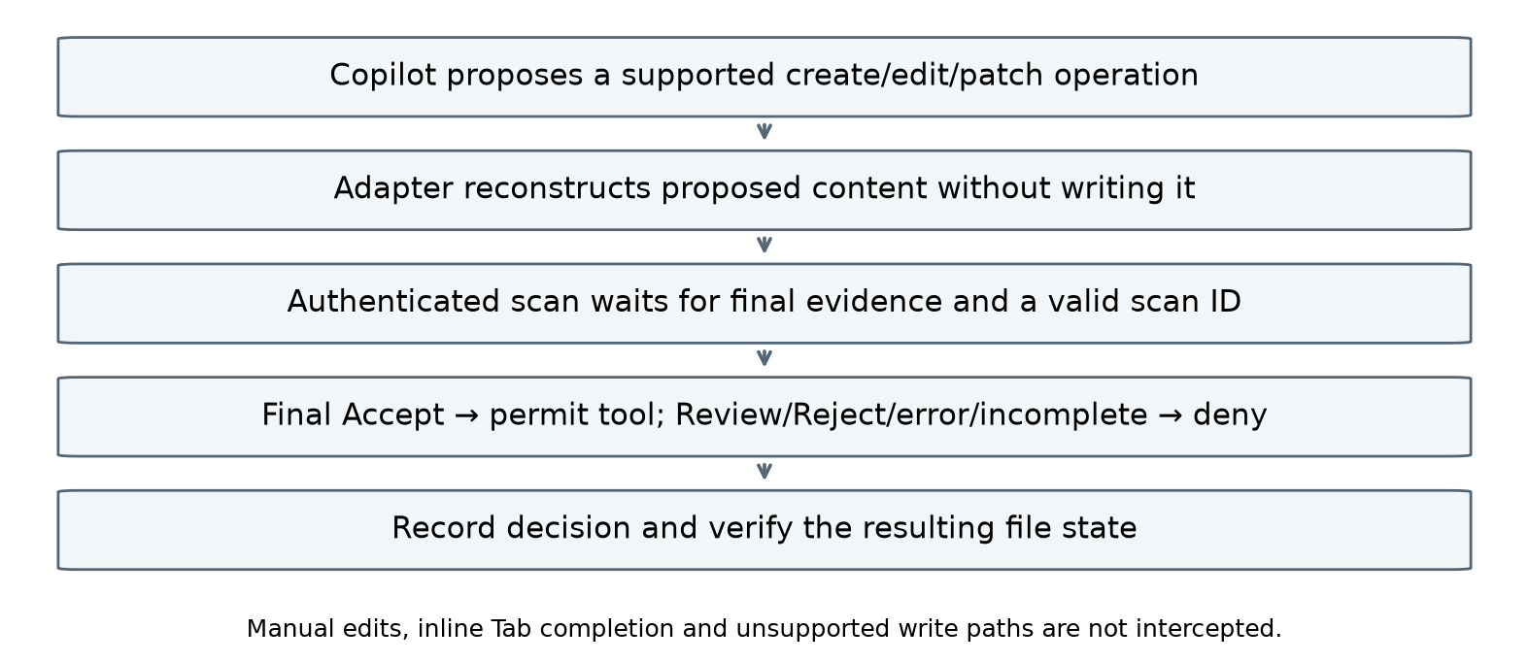
Figure 4.9. Implemented PreToolUse gate and its enforcement boundary. The actual SDK safe/unsafe pair verified both permit and deny paths.

Chapter 5

Testing, Results and Discussion

5.1 Test environment and method
This chapter separates dated historical back-end measurements from the latest 17–18 October checks. Current evidence is retained under .data/project-results-20261017, evaluation/trust_model/v3, evaluation/trust_model/final-ai-pilot-20261018 and output/human-reviewed-evaluation-20261018. Earlier verification remains historical. The following categories are assessed separately.
• Automated checks – pytest, one set per service and also one set for the utility scripts, as well as ensuring that the cloned contract and runtime are in sync.
• Integration checks: separately migrated scratch PostgreSQL persistence/locking, nine distinct browser cases, earlier VS Code extension-host checks, actual Copilot supported-tool enforcement, and matching scan-history/PDF retrieval.
• Evaluation scripts – the schema audit, the artificial trust model experiment, the public prompt injection test suite and the latency benchmark for the older backend.
• Live scans through the dashboard, the API and VS Code, including attacks against our own callback endpoint.
Passing the test indicates that the code does everything that is expected from it by the test. It does not indicate that the code can detect all actual defects. Hence, we cannot provide detection accuracy for the whole platform as a single number. We state the results and their dates and scope of application, as well as absence of the data.

5.2 Automated test suite
Table 5.1 reports the latest result for each component suite. The 729 Python total is an aggregate of distinct cases across the latest suites: 388 detector cases, 219 ordinary Trust Engine cases, one separately completed PostgreSQL case and 121 utility cases. The PostgreSQL case was skipped without its scratch-database configuration and passed separately on 18 October; it is counted once. Browser and extension-host cases are not added to this Python denominator.
Table 5.1. Latest component-suite results on 17 and 18 October 2026
Suite | Passed | Skipped
code_security | 70 | 0
docker_security | 77 | 0
secret_detection | 37 | 0
workflow_cicd | 31 | 0
license_compliance | 43 | 0
cipherguard | 44 | 0
prompt_injection | 86 | 0
trust_engine | 220 | 0
utilities (scripts/tests) | 121 | 0
Total | 729 | 0

The changed code-security and CipherGuard suites passed 70 and 44 tests respectively after deployment fixes. The other latest detector suites passed 77 Docker, 37 secret, 31 workflow, 43 licence and 86 prompt tests. Utility checks passed 121 cases, including 63 hook-adapter cases. Nine distinct browser cases are a separate denominator. These records do not mean that one new command reran all components simultaneously.

5.3 Schema conformance audit
The first integration problem was that the seven detectors, written by three people, did not agree on the result format. We wrote a script, evaluation/phase_a_schema_audit/audit.py, that sends one deliberately problematic sample to every detector through the running stack and checks the reply against the trust_engine schema. Table 5.2 is the final run of that audit on the earlier back end. The test fails if a reply has no findings, so a blank answer cannot pass.
Table 5.2. Schema audit on the earlier back end, final run (historical)
Detector | Status returned | Findings | Conforms
cipherguard | fail | 3 | Yes
code_security | fail | 1 | Yes
docker_security | warn | 7 | Yes
license_compliance | warn | 2 | Yes
prompt_injection | fail | 1 | Yes
secret_detection | warn | 1 | Yes
workflow_cicd | fail | 3 | Yes

The audit found real problems. The status array contained only four values in some detectors, which thus excluded the possibility of getting error, stub, and pending statuses again. The secret detector had the confidence level value of 30.0, but the schema calls for a value ranging from 0 to 1 (currently the value reported is 0.3). Some detectors had fields that violated the trust_engine contract, and the license detector could not safeguard against non-manifest input. The code security crash path returned fail and was changed to error. All of these were fixed in the commits of 18 and 19 September and 3 October.
In the final version, the contract has grown by the coverage, unresolved, decision_floor and hard_block fields. Each service now has its own contract tests, and a script checks that the copies of the contract inside the services are identical. The recorded verification also ran the schema audit against the native services, and all seven replies conformed again.

5.4 Router, fusion and lifecycle tests
The trust_engine suite is the largest. Its tests are grouped by file: routing, state, fusion, callbacks, analyze, access, tenants and retention, persistence and privacy, machine-learning scoring and the PostgreSQL integration. Among other things, they check the following behaviour.
• Type resolution order: explicit type, then path, then content, and an unknown explicit type gives HTTP 422 instead of a guess.
• package-lock.json goes to the dependency detectors, while unsupported lockfiles such as yarn.lock and composer.lock go to no detector and get coverage none.
• Binary content and content over the size guard go to no detector; an unknown file goes to secret_detection only, with partial coverage.
• Each hard rejection rule rejects, also where the weighted score alone would say Accept, and an override never calls the trained model.
• error, stub, pending and unexecuted results are never counted as clean, and partial coverage cannot give Accept.
• A batch respects the file count and size limits, and history and PDFs are only visible to the tenant that owns the scan.
• A pending check that runs out of time becomes a final Review, and a late "pass" cannot change it afterwards.
• A missing or damaged model file falls back to the weighted score and never auto-accepts.

5.5 Code security results

5.5.1 Historical Semgrep baseline
The earlier back end used 37 Semgrep rules. Its test fixtures were one vulnerable and one clean file per language. We verified whether all rules fire on the vulnerable file, and also what the clean files generate. Table 5.3 is used for record keeping of that engine; it doesn't evaluate the current one.
Table 5.3. Semgrep rule coverage on the test fixtures (earlier back end, historical)
Language | Rules | Rules triggered by the vulnerable fixture | Findings on the clean fixture
Python | 10 | 10 of 10 | 1
JavaScript and TypeScript | 9 | 9 of 9 | 1
PHP | 9 | 9 of 9 | 2
Java | 9 | 9 of 9 | 1
Total | 37 | 37 of 37 | 5

All 37 rules fired on a file written to trigger them. The five findings on the clean files were false positives, caused by taint rules that treated string joining itself as the source. The fixture set was small, so these numbers described the fixtures and were not a false-positive rate for real code.

5.5.2 Current native engine
The current engine has its own tests: vulnerable code must produce the expected categories, clean code must produce no findings, a Dockerfile must return stub, partly broken code must still give findings with partial coverage, and the PHP rules must cover all categories. One test checks that the same finding keeps the same severity in JavaScript and in Python. This replaces the old language weighting. Table 5.4 shows what one high finding at confidence 0.85 now costs, if it is the only finding.
Table 5.4. Cost of one high-severity finding in each language (current engine)
Language | Severity | Risk cost | Score if it is the only finding
Python, JavaScript, TypeScript, PHP, Java, Go | high | 25 x 0.85 = 21.25 | 78.75 (Review)

Using the old weights, the corresponding finding for JavaScript would have been rated at 91.5, within the Accept range. Removing that rule made the result the same in every language. We saw the 78.75 result ourselves in VS Code (Section 5.8).

5.6 Workflow security results
On the earlier back end, we scanned three small GitHub Actions files with the workflow detector. The first used a commit SHA and read-only permissions. The second used pull_request_target and a tag-pinned action. The third had write-all permissions, branch-pinned and unpinned actions and a curl-to-bash step. Table 5.5 gives the results of that run.
Table 5.5. Workflow detector on three sample files (earlier back end, historical)
Sample | Findings (severity) | Status | Risk score
Clean (SHA pin, read-only permissions) | None | pass | 100
pull_request_target and a tag-pinned action | Unpinned action (medium); missing permissions block (high) | fail | 72
write-all, branch and no-ref actions, curl to bash | Two unpinned actions (high); broad permissions with pull_request_target (critical); curl-pipe-bash (high) | fail | 0

The scores separated the clean file from the risky ones, and the worst file reached zero. The final version adds GitLab CI. Its tests check that remote execution inherited through templates is found, that files with includes cannot get full coverage, that cyclic templates give an error and that a clean, pinned job completes. We did not measure new risk scores for GitLab files, so none are reported here.

5.7 Latency
The benchmark script (evaluation/latency_benchmark.py) sent requests to trust_engine one at a time and logged the total time of each. It made 30 requests for each of four artifact types, 120 in total. This was done on the earlier back end and its settings. It measured the first, synchronous answer only, not the time until a background check finished. These numbers are therefore a historical measurement and not a promise about the current system.
Table 5.6. Historical synchronous HTTP latency on the earlier back end, 30 requests per artifact type; background finalisation excluded
Artifact type | Detectors | p50 (ms) | p95 (ms) | Within 3,000 ms
workflow | 2 | 31 | 46 | Yes
dockerfile | 2 | 863 | 947 | Yes
dependency | 3 | 375 | 514 | Yes
code | 3 | 2,254 | 2,457 | Yes
All 120 requests | - | 519 | 2,305 | Yes

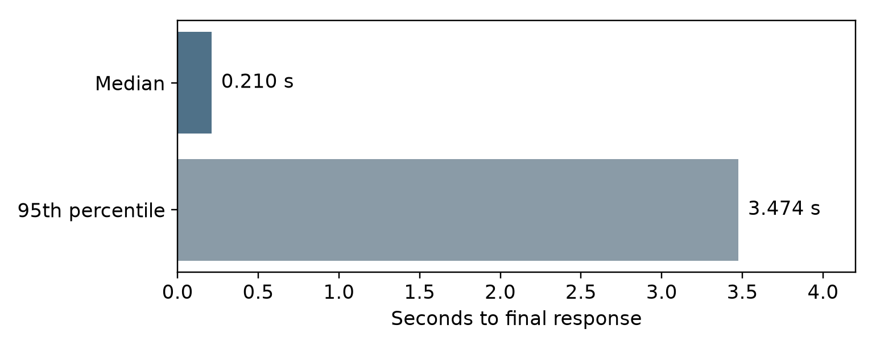
Figure 5.1. Final-response latency for the 18-case first-use pilot: serial loopback requests, median 0.210 s and p95 3.474 s; not a load benchmark.
Table 5.6 retains the earlier synchronous benchmark for historical comparison. Figure 5.1 uses the newer 18-case pilot and measures final responses. The cohorts and timing endpoints differ, so these measurements must not be interpreted as a controlled performance improvement.
A new small serial loopback pilot of 18 text-scope requests finalized with median 0.21 s and p95 3.47 s. It is separate from the 120-request historical synchronous benchmark and includes different artifacts and settings. Neither establishes cold-start behaviour, concurrent-load capacity or a universal three-second finalisation target.

5.8 End-to-end scans
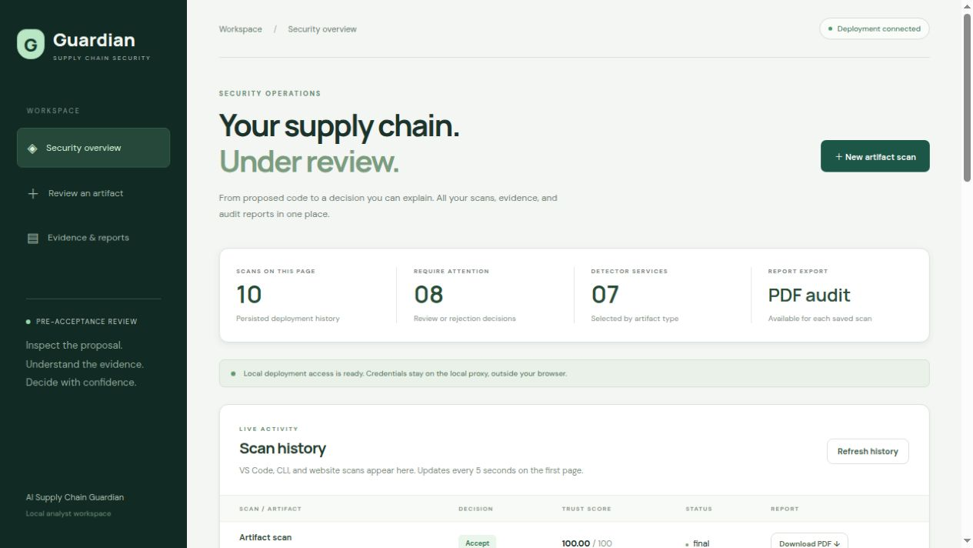
Figure 5.2. Current dashboard overview and persisted scan history, captured on 18 October 2026. History updates and report export share the authenticated deployment.
To see the final system work, we used the dashboard, the API and VS Code. Table 5.7 provides a summary of observations made, along with their sources and scope.
Table 5.7. Live and recorded scans of the final version
Evidence | Observed result | Scope
Manual VS Code scan of unsafe.py (eval on user input) | Review, 78.75/100; code_security reports dynamic Python execution at line 2. | Our own screenshot, 15 and 16 October; one file only.
Dashboard scan of test.py (eval and os.system with user input) | Review, 57.50/100, final, full coverage, weighted scoring; two high findings (unsafe_eval at line 3, command_injection at line 4), 21.2 points each; secret and prompt checks passed. | Our own run on a Windows laptop with Docker Compose, 16 October.
Saved dashboard demonstration | Final Reject, score 0, critical prompt-injection finding; the audit PDF button is visible. | Saved screenshot, Figure 5.3.
Saved dashboard Accept view | Accept 100/100, final, full coverage; LICENSE.txt with no findings from the licence and secret detectors. | Current dashboard capture on 18 October; applies only to this saved scan and its coverage.
Automated API and client checks | Authenticated history, saved result, PDF export and CLI behaviour recorded. | Saved verification records; not run again for this report.
VS Code extension host | Command, diagnostic location, scan on save, cancelling stale results and handling an unavailable server recorded. | Saved extension-host log; separate from the manual check.
Real browser | Nine distinct browser cases passed in separately recorded runs. | Specific dashboard behaviours only.

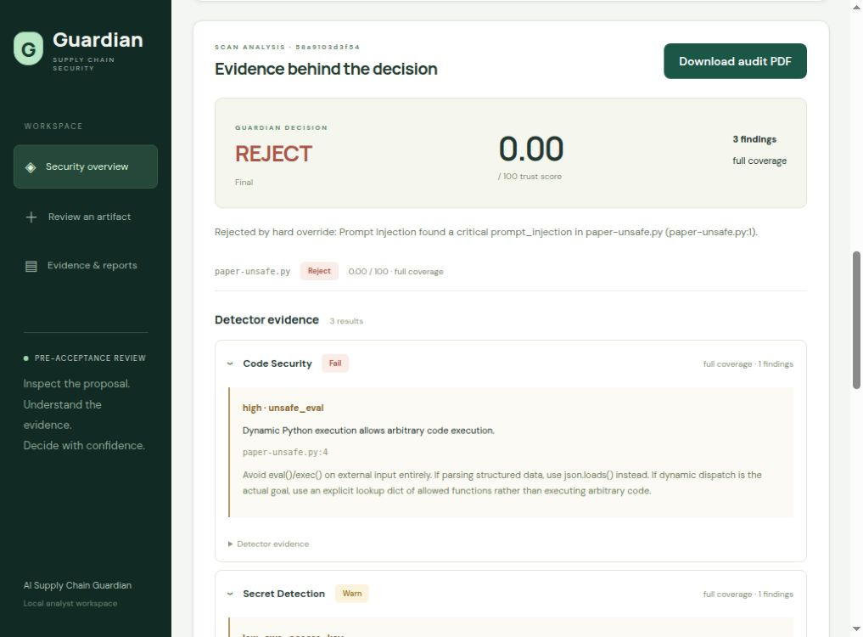
Figure 5.3. Redesigned dashboard showing a saved Reject 0/100 result, detector findings and the audit PDF control; recorded 17 October 2026.
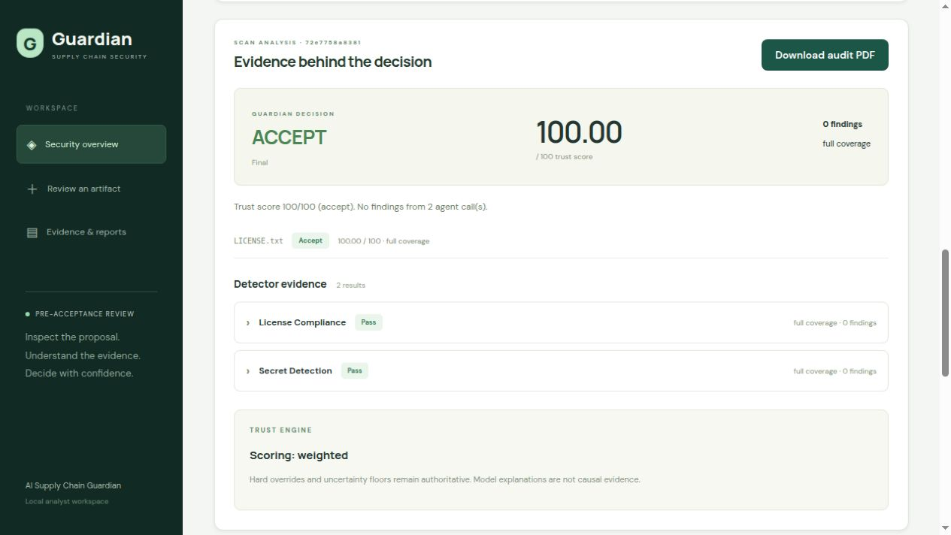
Figure 5.4. Current dashboard captured on 18 October 2026: saved LICENSE.txt scan, Accept 100/100, full coverage and audit PDF export. This verdict applies only to that scan.
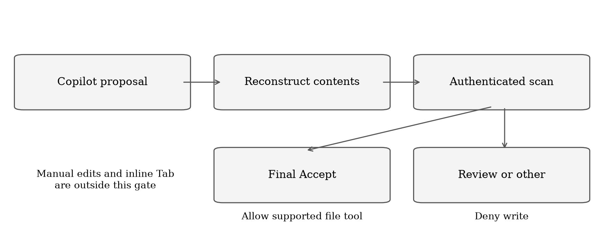
Figure 5.5. Supported Copilot pre-write gate: only a final Accept permits the file tool. Actual safe and unsafe proposal evidence is described below; this is a process diagram, not a VS Code screenshot.
Actual Copilot SDK proposals passed through the same PreToolUse adapter: safe addition was allowed at 100/100 (scan 5a0d347495014e28b0fe7e5eb9b10fd0); unsafe eval was denied at Review 78.75/100 (538450cf12bb4e9c9481fdc310b2d75c), and its file remained absent. Both saved results and audit PDFs were verified. This demonstrates supported-tool enforcement, not interception of every editor action.
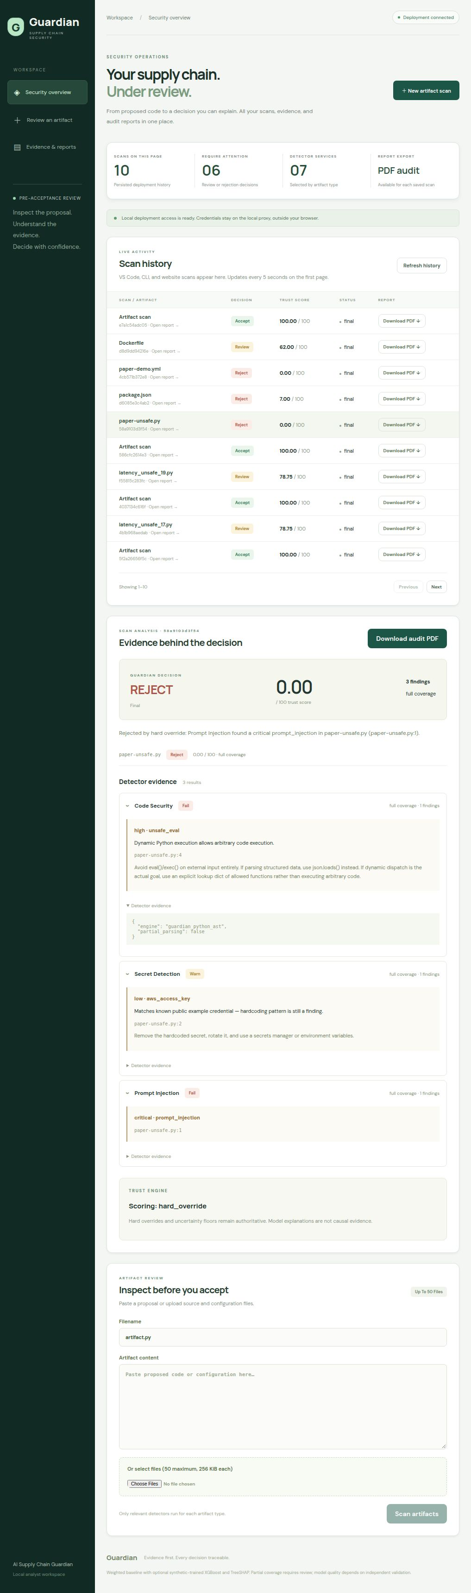
Figure 5.6. Recorded code-security detector panel from the redesigned website, 17 October 2026. Status, findings and coverage apply to the matching saved artifact.
Figure 5.7. Recorded secret-detection detector panel from the redesigned website, 17 October 2026. Status, findings and coverage apply to the matching saved artifact.
Figure 5.8. Recorded prompt-injection detector panel from the redesigned website, 17 October 2026. Status, findings and coverage apply to the matching saved artifact.
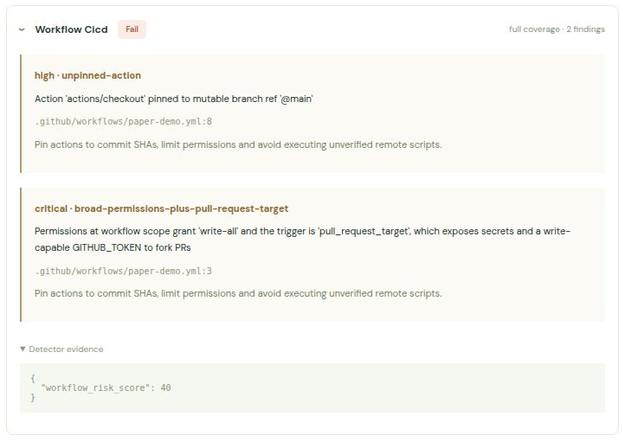
Figure 5.9. Recorded workflow-security detector panel from the redesigned website, 17 October 2026. Status, findings and coverage apply to the matching saved artifact.
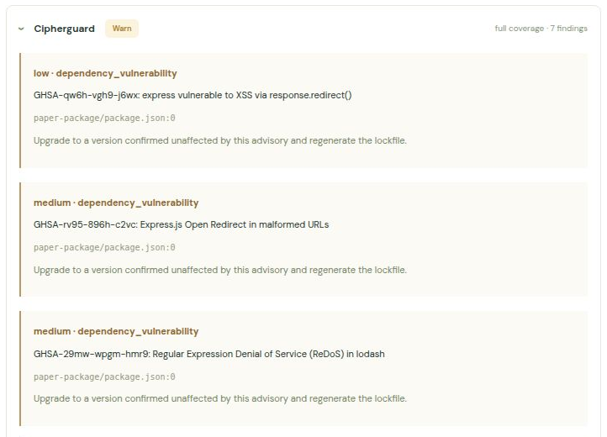
Figure 5.10. Recorded package-risk detector panel from the redesigned website, 17 October 2026. Excerpt shows the first findings; the saved response contains the complete evidence.
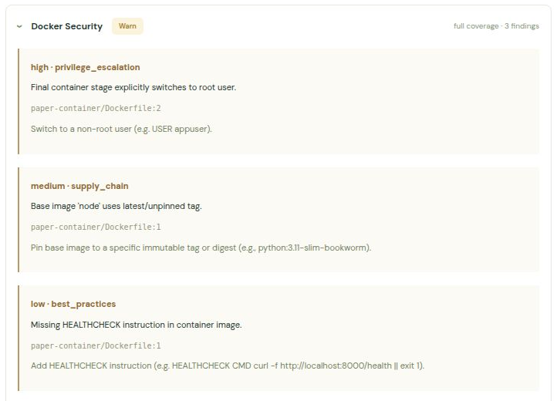
Figure 5.11. Recorded container-security detector panel from the redesigned website, 17 October 2026. Excerpt shows the first findings; the saved response contains the complete evidence.
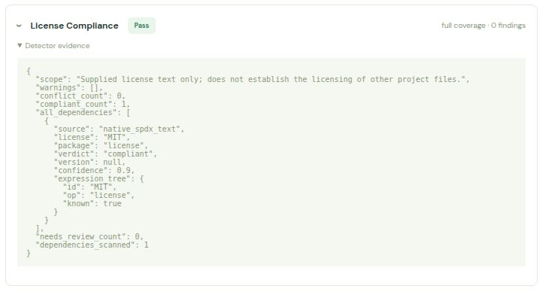
Figure 5.12. Recorded licence-compliance detector panel from the redesigned website, 17 October 2026. Status, findings and coverage apply to the matching saved artifact.
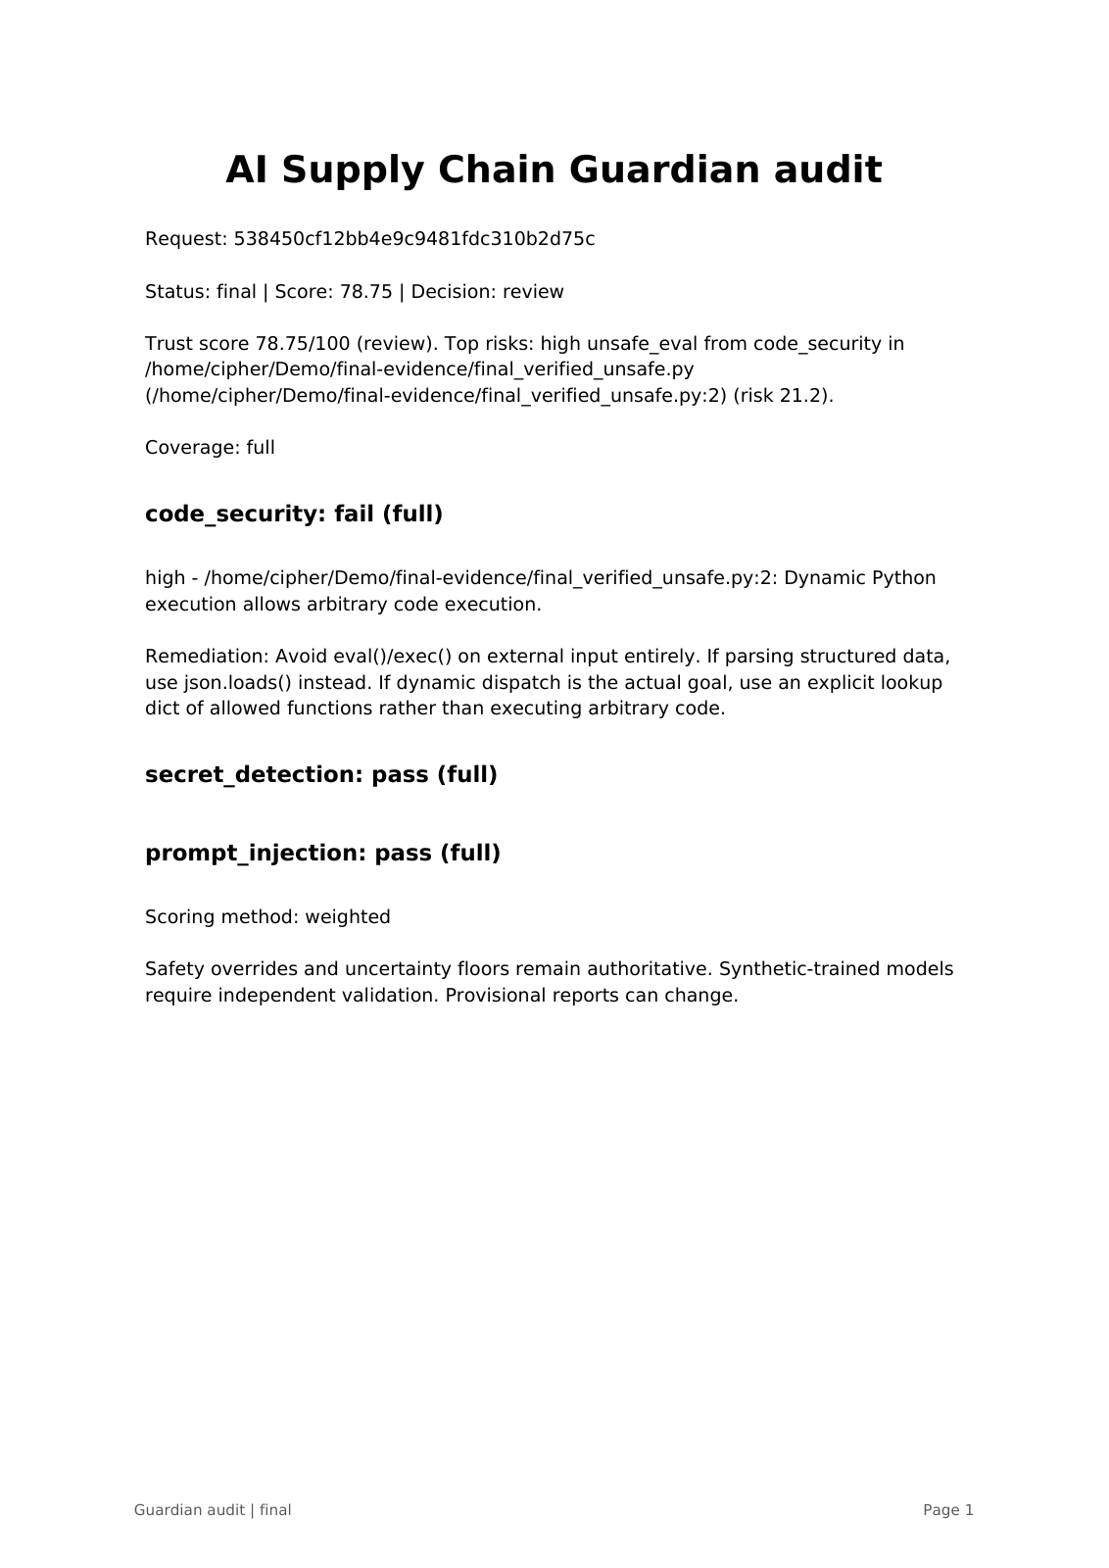
Figure 5.13. First page of the actual 18 October Copilot unsafe-proposal audit PDF: scan 538450cf12bb4e9c9481fdc310b2d75c, Review 78.75/100. The hook denied the write. This is a saved PDF rendering, not a terminal capture.

5.9 Security review of the callback pull requests
This review was done on the earlier back end, and it is kept here as a lesson from development. Two pull requests changed the asynchronous path. The first (number 2) added the pending state, the callback endpoint and the Redis store. The second (number 3) changed the handling of a failed judge. We reviewed both by reading the code and then by testing the running system. Table 5.8 lists what was found and where each issue stands in the final version.
Table 5.8. Findings from the pull request review
Finding | How it was found | Effect | Fix and current state
Callback endpoint had no authentication | Forged callback sent with curl on the running stack | A fake pass changed a file that held an injection sentence from Review to Accept | X-Callback-Token with constant-time compare; separate from client keys. A regression test still checks the forged request.
Redis port published to the host | Reading docker-compose.yml | Anything on the network could rewrite stored scans | Port closed. Redis is no longer the record of a scan.
A high finding could still be Accept | Reasoning about the score formula | Low-confidence high finding leaves score above 80 | Severity floor added to fusion
Callback could arrive before the scan was saved | Reading the order of operations | Final result lost after a 404 | Detector retried at first; now the provisional scan is saved first and updates are locked.
Failed LLM judge counted as not an injection | Running the stack with no key and with a wrong key | Unknown input could be accepted | Detector returns error; fusion floors at Review.

The most useful part of the review was the first item. It was not found by reading the code alone. It was found by writing the attack and running it. This changed the way the team tested the later work.

5.10 Research evaluation

5.10.1 Synthetic trust-model pilot
The synthetic corpus contains 360 project-authored artifacts with grouped 180/90/90 train/validation/test partitions and engineering targets 100, 65 and 0. Earlier errors in this corpus were inspected while developing the system; the latest 90 test-labelled cases are therefore a development retest, not an untouched final holdout. The latest comparison uses one fresh supplied-text detector response set for weighted scoring and both frozen v2 and retrained v3 model replay. Synthetic labels have not received independent human review.
Table 5.9. Weighted scoring and the XGBoost v3 candidate on 90 synthetic development cases
Test metric | Weighted baseline | XGBoost v3 candidate
Development cases | 90 | 90
Verdict agreement | 77.78% (70/90) | 83.33% (75/90)
Score MAE | 19.58 | 13.11
False accepts | 0 | 0
Default | Yes | No

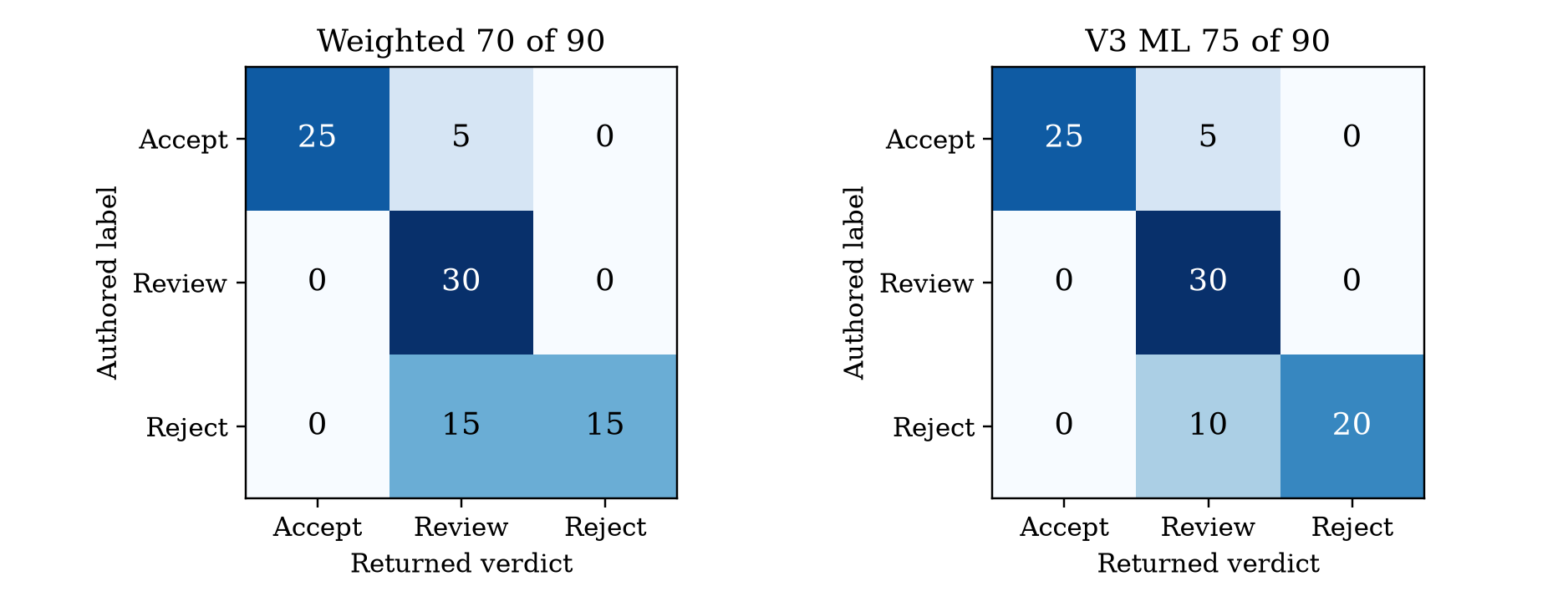
Figure 5.14. Latest 90-case synthetic development confusion matrices: weighted agreement 77.78% and v3 ML 83.33%; rows are authored labels, columns returned verdicts.
On 90 previously inspected synthetic development cases, weighted scoring agreed with 70 labels (77.78%, MAE 19.58); frozen v2 and retrained v3 each agreed with 75 (83.33%, MAE 14.23 and 13.11). A separate 18-case AI-labelled first-use pilot gave 66.67% weighted and 61.11% ML agreement, with three false accepts each. Two detector fixes raised weighted retest agreement to 77.78%, leaving one false accept. On ten project-team human-reviewed upstream files, fresh weighted and v2 agreement was 30%, and v3 replay 20%; six of eight human-Accept files were blocked. These inspected cohorts do not establish generalization.
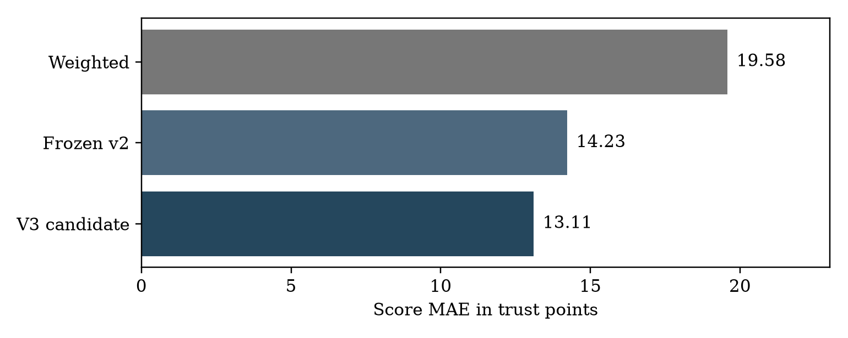
Figure 5.15. Score MAE on the same inspected 90-case development observations: weighted 19.58, frozen v2 14.23 and v3 13.11. Engineering targets are not attack probabilities.
Native and library TreeSHAP contributions agreed with maximum difference zero in the recorded matrix. No violations occurred in 3,360 observed-feature monotonic checks. In the separate 18-case first-use pilot, maximum native SHAP additivity residual was 0.0000153 for v2 and 0.0000458 for v3. These are implementation checks, not proof of calibration, causality or correct labels. Weighted deployment has no active model SHAP explanation.
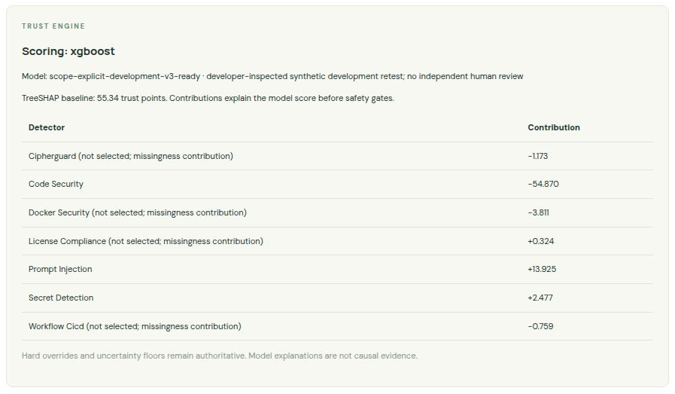
Figure 5.16. Native v3 model and TreeSHAP explanation in the separate ML preview deployment, captured 18 October local time. Weighted scoring remains the normal deployment default.
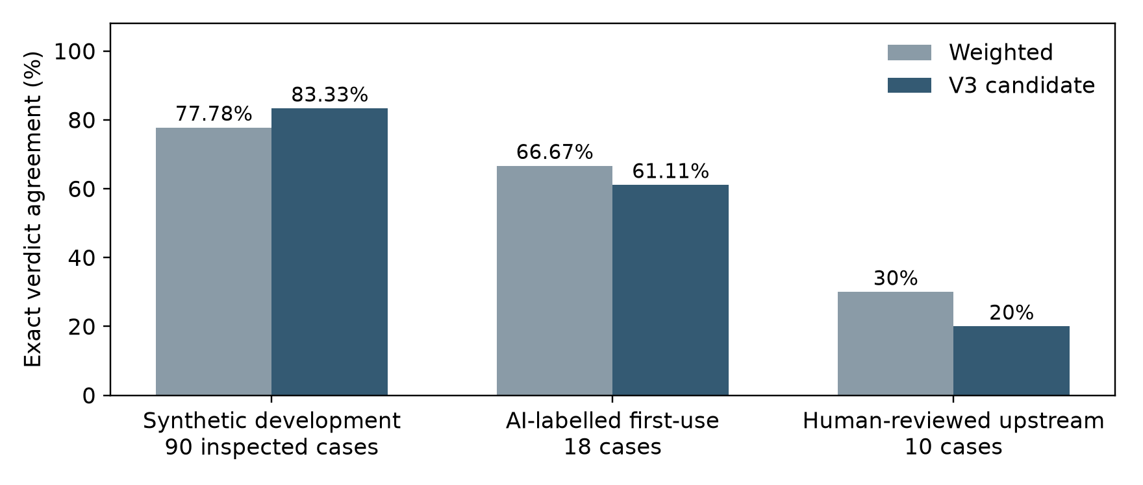
Figure 5.17. Separate evaluation cohorts give different agreement rates. The human review is project-team, self-attested and not blinded; no Reject-labelled files occur in its ten cases. These cohorts must not be pooled.

5.10.2 Public prompt-injection test
We also ran the prompt-injection detector on a public data set, deepset/prompt-injections (deepset, n.d.), revision 4f61ecb038e9c3fb77e21034b22511b523772cdd, test split, 116 rows. Each prompt was sent as the text of a README file. The judge was Groq with openai/gpt-oss-20b. This split had been looked at before, so it is not a fresh hold-out set, and we cannot know whether the LLM saw these prompts during its own training. Table 5.10 gives the counts.
Table 5.10. Public prompt-injection test (deepset, 116 rows)
Outcome | Count
Attacks found (true positives) | 48
Attacks missed and accepted (false negatives) | 10
Benign prompts left alone (true negatives) | 47
Benign prompts flagged (false positives) | 9
No usable answer (unknown) | 2
Total | 116

Ten attack-labelled prompts were accepted in the earlier public test. This is a documented detection weakness. Direct prompts embedded as README text differ from realistic indirect repository attacks; a separate representative, independently reviewed dataset is needed. Current human-labelled upstream results additionally expose benign-file overblocking.

5.10.3 Other comparisons
• CipherGuard: the source code of four open-source tools was read and compared (Table 4.6). It is a comparison of design and not of detection rates.
• License compliance: on the earlier back end, a manifest of 55 packages was run through our agent, pip-licenses and ScanCode. Our agent gave a licence for each package with its source and confidence; pip-licenses had to skip two items because it only reads installed packages.
• Prompt injection: a harness runs the detector next to llm-guard, Rebuff and Vigil on the same cases. We did not keep a summary table that we could verify, so we give no rates for that comparison.

5.11 Limitations and known problems
Implemented fixes include scope-explicit Docker scans with bounded retries, a blocked Markdown authority case, password-function context in weak-hash rules, and install-lifecycle network-to-shell detection. Remaining limitations are listed in Table 5.11. Later evaluation subsections retain first-use results separately from post-fix development retests.
Table 5.11. Known limitations of the final version
Limitation | Effect
Prompt-injection misses and unknown answers | The public test accepted 10 attacks and gave 2 unknown answers. Protection against indirect attacks is not proven.
Synthetic trust labels | The 360 construction labels remain unreviewed by an independent person. Ten separate upstream files now have self-attested project-team human labels; this is not an untouched holdout.
Code analysis inside one function | Supported rules only; no proof that a whole program is secure.
Dependency resolution limits | At most 100 registry checks per artifact. Incomplete graphs and replaced sources lower coverage.
Rust and Go package checks | Less data on package age and name similarity; Go licences are often unknown.
Container image scope | Only public Docker Hub linux/amd64 Alpine and Debian images. Language packages need their own scan.
External data | Registries, image data and vulnerability feeds can rate-limit or be unavailable.
Licence ambiguity | Changed or unknown licence texts need review. This is not legal advice.
Dockerfile fix suggestions | Not built or tested.
Public deployment | Trusted TLS, backups, load targets and outside security review would still be needed.
Editor scope | Command/save diagnostics are separate from the configured supported-tool PreToolUse gate. Inline completions and arbitrary editor writes are outside enforcement.
Repository documents | Dated snapshots use different cohorts and settings. This report names the latest source paths and keeps historical results separate.

5.12 Selected test cases and results
Table 5.12 lists selected existing regression cases. Earlier runs are retained as dated history; the latest component suites and separately configured PostgreSQL case provide the updated aggregate in Table 5.1. A passing regression case establishes the specific asserted behaviour, not detection completeness.
Table 5.12. Selected test cases
ID | Condition (test file) | Expected result | Result
TC-01 | package-lock.json (test_routing) | Routed to cipherguard, license_compliance and secret_detection | Pass
TC-02 | yarn.lock or composer.lock (test_routing, test_analyze) | No detector is called; coverage none; never accept | Pass
TC-03 | Explicit type that does not exist (test_analyze) | HTTP 422, not 500 | Pass
TC-04 | Explicit type against the file name (test_routing) | Explicit type wins and a note is recorded | Pass
TC-05 | Content sniffing when a filename exists (test_routing) | Sniffing is skipped | Pass
TC-06 | Binary content (test_routing) | No detector is called; coverage none | Pass
TC-07 | Unknown file type (test_routing) | secret_detection only; coverage partial | Pass
TC-08 | A status that is not in the list (test_state) | Rejected by validation | Pass
TC-09 | Each hard override (test_fusion) | Reject even where the weighted score alone says accept | Pass
TC-10 | CipherGuard score below 90; secret below confidence 0.85 (test_fusion) | No override | Pass
TC-11 | Override with the model selected (test_ml_scoring) | The model is never called | Pass
TC-12 | Missing or invalid model file (test_ml_scoring) | Weighted fallback; fallback is explicit and floors the result at Review | Pass
TC-13 | Result claimed clean without running (test_ml_scoring) | Never accept | Pass
TC-14 | Batch, history, PDF and limits (test_checkpoint2) | Per-file results, history and PDF work; limits refuse bad batches | Pass
TC-15 | Another tenant's scan, history or PDF (test_tenants_retention) | Access denied | Pass
TC-16 | Retention clean-up (test_tenants_retention) | Old final scans removed; pending ones kept | Pass
TC-17 | PostgreSQL cross-store persistence and row lock (test_postgres_integration) | Saved state is read by a second store; concurrent callback updates are serialised | Pass
TC-18 | Callback with no token configured (test_callback) | 503; nothing changes | Pass
TC-19 | Forged pass for a pending scan (test_callback) | Refused; the scan stays provisional | Pass
TC-20 | Callback with an unknown id (test_callback) | 404 | Pass
TC-21 | Pending check past its deadline (test_checkpoint2) | Final Review; a late pass cannot change it | Pass
TC-22 | Separate client and callback keys in production settings (test_access) | Weak or shared keys refused | Pass
TC-23 | Same finding in JavaScript and Python (code_security) | Same severity | Pass
TC-24 | Dockerfile sent to the code detector (code_security) | Status stub | Pass
TC-25 | GitLab include and inherited remote execution (workflow_cicd) | Found; files with includes stay partial | Pass

The trust_engine tests are in services/trust_engine/tests, the code security tests in services/code_security/tests/test_analyze.py and the GitLab tests in services/workflow_cicd/tests/test_gitlab.py.

5.13 Discussion
The strongest result of the project is about behaviour, and not about detection. All the places where a detector would have said “I don’t know” have become places where “Review” is now stated. The Error Status, Partial Coverage, Unresolved Status, Checks due at a certain date, Severity Threshold, and Hard Rules all point in the same direction, and the model cannot override them. We learned this by finding the opposite behaviour in our own code: a crash that looked like a failure, an unsupported file that looked like a pass, a failed judge that looked like a clean file, and a forged callback that looked like a clean result.
Secondly, it means that the system is user friendly. This is because one is able to calculate from either the dashboard, the command line, VS code, keep a history and download a PDF and get the exact results in all instances: the 78.75 and 57.50 obtained are equal to the equation. The price is complexity. The final version has a database, tenants, a callback token, background jobs and a deadline for them, which is much more to run than the first back end.
Detection quality remains the main weakness. A previous public prompt test missed ten attacks. In the human-reviewed upstream cohort, weighted agreement is 30% and v3 model replay agreement 20%; weighted policy blocks six of eight files the reviewer accepted. The ten-file review is small, project-team and self-attested, with no Reject-labelled samples. These findings limit production claims even though integration tests pass.

Chapter 6

Conclusion and Future Scope

6.1 Conclusion
AI Supply Chain Guardian implements artifact review with seven routed detector services, deterministic policy gates, authenticated client interfaces, tenant-scoped SQL history and audit PDF export. A configured VS Code Local PreToolUse gate has also been demonstrated on actual supported safe and unsafe file proposals before writing. This enforcement applies to the configured tool path, not every editor or assistant action.
The optional XGBoost regressor and exact TreeSHAP explanation path are implemented, but the model remains unpromoted. Its 83.33% agreement on inspected synthetic development cases does not generalize to the ten human-labelled upstream files, where v3 replay achieved 20%. The completed human review and successful technical checks document a working prototype with measured limitations, not independent production assurance.
Table 6.1 summarizes the goals established in Chapter 1 and shows how well they have been accomplished.
Table 6.1. Objectives and outcome
No. | Objective | Outcome
O1 | Seven detectors with one result format | Achieved. Contract tests in each service; schema audit passed.
O2 | Routing with a coverage value | Achieved. Detectors are chosen per file type; coverage is shown in every result.
O3 | Score and decision with a written reason | Achieved. The same formula gave 78.75 in VS Code and 57.50 in the dashboard.
O4 | Unknown is never clean | Achieved. Error, pending, unresolved and partial results all hold the decision at Review or worse.
O5 | Slow checks in the background with a secure callback | Achieved. Separate callback token, locking and a deadline for pending checks.
O6 | History and developer tools | Achieved. SQL history, PDF, dashboard, CLI and VS Code; an actual supported-tool safe/unsafe pair verifies pre-write allow and deny.
O7 | Trained scorer that cannot override the safety rules | Built and tested on synthetic and ten human-labelled external files; candidate remains unpromoted.

6.2 Project outcome
Comparison of what was intended with what is actually the case in the final version is given in Table 6.2. The status field is written very precisely: “implemented” implies existence of the code with successful tests, not successful implementation in practice.
Table 6.2. Planned and achieved outcomes
Planned | Status | Evidence
Seven services and a common evidence contract | Implemented; detectors are chosen per artifact type | Chapter 4; Table 5.1
Routing and rule-based fusion | Implemented; the caution rules always have the last word | Sections 4.3 and 4.5
Database and history | Implemented with SQL snapshots, findings, detector runs and tenant scope | Section 4.8; TC-15 to TC-17
Dashboard, command-line tool and editor | Implemented; browser and extension-host tests recorded; manual VS Code check on one file | Section 5.8
Trained model for the score, with explanations | Optional candidate; 20% v3 agreement on ten human-labelled files; not promoted | Section 5.10
Final scans under three seconds | Not established. An 18-case serial pilot gave median 0.210 s and p95 3.474 s; no load guarantee. | Section 5.7
Reliable detection across all security problems | Not shown; the public prompt test still has misses | Sections 5.10 and 5.11
Approval for a public production release | Not given by our verification | Section 5.11

Three of the eight lines are not achieved. We keep them in the table because they affect what the project can honestly be used for today: it is a working review tool for a team, not a proven security product.

6.3 What we learned
• An agreed data contract at the start saves a lot of integration work. Our schema audit came later and found problems that could have been caught earlier.
• The difference between "no finding" and "not checked" changes many small code decisions, from the status values to the coverage field.
• A security fix has to be tested by attacking it. The forged callback was not found by reading the code.
• A passing test suite does not tell you what is missing. Gaps such as the unrouted PHP and Java files and the missing Go rules were found only when we compared the router with the rules.
• A report has to keep up with the code. Our first draft described an older version, and parts of it had to be rewritten once the final repository was checked.

6.4 Future scope
Table 6.3. Future work in order of priority
Work | Why it matters
Minimize instances of missed injections and test using real-world indirect attacks reviewed by someone outside of the group | The public test was able to accept 10 attacks; indirect attacks in repositories were not tested.
Obtain real-world trust labels independently and then calibrate and retest the trained scorer | The present external comparison is weak; promotion requires broader reviewed data and an untouched project/family evaluation, not tuning to inspected cases.
Extend dependency, Go licence and build-context coverage | Reduces the cases that end as partial coverage.
Increase registry, vulnerability, and image data reliability, for instance by using an authenticated mirror or offline copy | Public feeds can rate limit or fail during a scan.
Build and test the suggested Dockerfile fixes | Today they are only suggestions.
Measure load, recovery, backup restore and public TLS for a real deployment | Needed before use outside a team environment.
Make the editor workflow easier to use, without claiming to control other AI tools | The check is most useful where the developer already works.

Priority work is to reduce benign prompt uncertainty and context-insensitive findings, broaden independently reviewed project/family data, and freeze a new holdout before evaluation. Improving these diagnostics must not turn the ten already-inspected upstream files into a purported untouched test. Public deployment additionally needs measured load/recovery, trusted TLS, backup restoration and external security review.

6.5 Final remark
The project started off with a simple inquiry. Can a developer obtain one clear reply regarding an AI-generated file prior to accepting it? The system gives that answer, and where it cannot give one it says so. We think that second part is the more important one.

REFERENCES
Chen, T., & Guestrin, C. (2016). XGBoost: A scalable tree boosting system. In Proceedings of the 22nd ACM SIGKDD International Conference on Knowledge Discovery and Data Mining (pp. 785–794). Association for Computing Machinery. https://doi.org/10.1145/2939672.2939785
Chennabasappa, S., Nikolaidis, C., Song, D., Molnar, D., Ding, S., Wan, S., Whitman, S., Deason, L., Doucette, N., Montilla, A., Gampa, A., de Paola, B., Gabi, D., Crnkovich, J., Testud, J.-C., He, K., Chaturvedi, R., Zhou, W., & Saxe, J. (2025). LlamaFirewall: An open source guardrail system for building secure AI agents. arXiv. https://arxiv.org/abs/2505.03574
deepset. (n.d.). prompt-injections [Data set]. Hugging Face. Retrieved October 16, 2026, from https://huggingface.co/datasets/deepset/prompt-injections
Docker Inc. (n.d.). Building best practices. Docker Docs. Retrieved October 14, 2026, from https://docs.docker.com/build/building/best-practices/
GitHub. (n.d.). Secure use reference. GitHub Docs. Retrieved October 14, 2026, from https://docs.github.com/en/actions/reference/security/secure-use
Greshake, K., Abdelnabi, S., Mishra, S., Endres, C., Holz, T., & Fritz, M. (2023). Not what you've signed up for: Compromising real-world LLM-integrated applications with indirect prompt injection. In Proceedings of the 16th ACM Workshop on Artificial Intelligence and Security (pp. 79–90). ACM. https://arxiv.org/abs/2302.12173
Hackett, W., Birch, L., Trawicki, S., Suri, N., & Garraghan, P. (2025). Bypassing LLM guardrails: An empirical analysis of evasion attacks against prompt injection and jailbreak detection systems. arXiv. https://arxiv.org/abs/2504.11168
Krishna, A., Galinkin, E., Derczynski, L., & Martin, J. (2025). Importing phantoms: Measuring LLM package hallucination vulnerabilities. arXiv. https://arxiv.org/abs/2501.19012
Lundberg, S. M., & Lee, S.-I. (2017). A unified approach to interpreting model predictions. In Advances in Neural Information Processing Systems (Vol. 30, pp. 4765–4774). Curran Associates.
MITRE. (n.d.-a). CWE-78: Improper neutralization of special elements used in an OS command ('OS command injection'). Common Weakness Enumeration. Retrieved October 14, 2026, from https://cwe.mitre.org/data/definitions/78.html
MITRE. (n.d.-b). CWE-89: Improper neutralization of special elements used in an SQL command ('SQL injection'). Common Weakness Enumeration. Retrieved October 14, 2026, from https://cwe.mitre.org/data/definitions/89.html
MITRE. (n.d.-c). CWE-798: Use of hard-coded credentials. Common Weakness Enumeration. Retrieved October 14, 2026, from https://cwe.mitre.org/data/definitions/798.html
National Institute of Standards and Technology. (2023). Artificial intelligence risk management framework (AI RMF 1.0) (NIST AI 100-1). U.S. Department of Commerce. https://doi.org/10.6028/NIST.AI.100-1
Open Source Security Foundation. (n.d.). Open Source Vulnerability format. Retrieved October 16, 2026, from https://ossf.github.io/osv-schema/
OWASP Foundation. (2025). OWASP top 10 for large language model applications 2025. Retrieved October 14, 2026, from https://genai.owasp.org/llm-top-10/
Pearce, H., Ahmad, B., Tan, B., Dolan-Gavitt, B., & Karri, R. (2022). Asleep at the keyboard? Assessing the security of GitHub Copilot's code contributions. In 2022 IEEE Symposium on Security and Privacy (pp. 754–768). IEEE. https://doi.org/10.1109/SP46214.2022.9833571
Perry, N., Srivastava, M., Kumar, D., & Boneh, D. (2023). Do users write more insecure code with AI assistants? In Proceedings of the 2023 ACM SIGSAC Conference on Computer and Communications Security (pp. 2785–2799). ACM. https://doi.org/10.1145/3576915.3623157
Reimers, N., & Gurevych, I. (2019). Sentence-BERT: Sentence embeddings using Siamese BERT-networks. In Proceedings of the 2019 Conference on Empirical Methods in Natural Language Processing (pp. 3982–3992). Association for Computational Linguistics. https://doi.org/10.18653/v1/D19-1410
Schreiber, M., & Tippe, P. (2025). Security vulnerabilities in AI-generated code: A large-scale analysis of public GitHub repositories. arXiv. https://arxiv.org/abs/2510.26103
Sentence Transformers. (n.d.). all-MiniLM-L6-v2 [Model card]. Hugging Face. Retrieved October 14, 2026, from https://huggingface.co/sentence-transformers/all-MiniLM-L6-v2
Shukla, S., Joshi, H., & Syed, R. (2025). Security degradation in iterative AI code generation: A systematic analysis of the paradox. In 2025 IEEE International Symposium on Technology and Society. IEEE. https://arxiv.org/abs/2506.11022
Souppaya, M., Morello, J., & Scarfone, K. (2017). Application container security guide (NIST Special Publication 800-190). National Institute of Standards and Technology. https://doi.org/10.6028/NIST.SP.800-190
Souppaya, M., Scarfone, K., & Dodson, D. (2022). Secure software development framework (SSDF) version 1.1: Recommendations for mitigating the risk of software vulnerabilities (NIST Special Publication 800-218). National Institute of Standards and Technology. https://doi.org/10.6028/NIST.SP.800-218
Spracklen, J., Wijewickrama, R., Sakib, A. H. M. N., Maiti, A., Viswanath, B., & Jadliwala, M. (2025). We have a package for you! A comprehensive analysis of package hallucinations by code generating LLMs. In 34th USENIX Security Symposium. USENIX Association. https://arxiv.org/abs/2406.10279
Tree-sitter. (n.d.). Introduction. Retrieved October 16, 2026, from https://tree-sitter.github.io/tree-sitter/
United Nations. (n.d.-a). Goal 9: Build resilient infrastructure, promote inclusive and sustainable industrialization and foster innovation. Department of Economic and Social Affairs. Retrieved October 14, 2026, from https://sdgs.un.org/goals/goal9
United Nations. (n.d.-b). Goal 16: Promote peaceful and inclusive societies for sustainable development, provide access to justice for all and build effective, accountable and inclusive institutions at all levels. Department of Economic and Social Affairs. Retrieved October 14, 2026, from https://sdgs.un.org/goals/goal16
Wang, W., Wei, F., Dong, L., Bao, H., Yang, N., & Zhou, M. (2020). MiniLM: Deep self-attention distillation for task-agnostic compression of pre-trained transformers. In Advances in Neural Information Processing Systems (Vol. 33, pp. 5776–5788). Curran Associates. https://arxiv.org/abs/2002.10957
Zhao, Y., Wu, M., Hu, X., & Xia, X. (2025). HFuzzer: Testing large language models for package hallucinations via phrase-based fuzzing. arXiv. https://arxiv.org/abs/2509.23835
Zimmermann, M., Staicu, C.-A., Tenny, C., & Pradel, M. (2019). Small world with high risks: A study of security threats in the npm ecosystem. In 28th USENIX Security Symposium (pp. 995–1010). USENIX Association. https://arxiv.org/abs/1902.09217

APPENDIX A: SAMPLE REQUESTS AND RESPONSES
The examples in this appendix were sent to the final version. Each request only contains text; Guardian reads the file and never runs it. The replies are shortened to the main fields, and they are dated, because a different scorer setting or new registry data can change a score.
A.1 One file through POST /analyze
{
"filename": "unsafe.py",
"content": "user_input = input()\neval(user_input)\n"
}
Historical manual VS Code observation on 15–16 October: Review 78.75/100 with a dynamic Python execution finding at line 2. The later supported-tool Copilot denial is independently retained with scan ID 538450cf12bb4e9c9481fdc310b2d75c and its audit PDF.
A.2 A file with two high findings, through the dashboard
import os
user_input = input()
eval(user_input)
os.system("ls " + user_input)
Observed in the dashboard on 16 October 2026 (filename test.py), shortened:
REVIEW 57.50 / 100 Final
Coverage: full Scoring: weighted
code_security fail high unsafe_eval test.py:3 risk 21.2
high command_injection test.py:4 risk 21.2
evidence: engine guardian_python_ast, partial_parsing false
secret_detection pass full coverage
prompt_injection pass full coverage
A.3 A batch through POST /analyze/batch
Each file in a batch is routed on its own. The Python file goes to code, secret and prompt checks, the Dockerfile to Docker and secret checks, the GitLab file to workflow and secret checks, and package.json to CipherGuard, licence and secret checks. No single file is expected to start every detector.
{
"files": [
{"filename": "safe.py", "content": "print(1)\n"},
{"filename": "Dockerfile", "content": "FROM alpine:3.20\n"},
{"filename": ".gitlab-ci.yml", "content": "build:\n script: echo demo\n"},
{"filename": "package.json", "content":
"{\"name\":\"demo\",\"dependencies\":{}}"}
]
}
This request shows the shape of a batch and the routing; it is not expected to produce a finding in every detector. An empty dependency list, for example, gives no package findings. We did not record a reply for this batch, so none is printed here.
A.4 The clean version of A.1
def run(user_input):
return user_input
With scan on save switched on in VS Code, saving this version replaces the earlier diagnostic. A result without findings still has to be read together with its coverage; it is not proof that the file is safe.

APPENDIX B: RUNNING THE SYSTEM AND THE TESTS
B.1 Start the stack with Docker Compose (Windows PowerShell)
These are the steps we used on a Windows laptop on 16 October 2026. Run them in the repository folder. On Windows, clone with Git line-ending conversion switched off, because the licence data files are checked against SHA-256 hashes.
git config --global core.autocrlf false
git clone https://github.com/Cipher-Sheild/AI_Supply_Chain_Guardian-v2.git
cd AI_Supply_Chain_Guardian-v2
copy .env.example .env
# in .env set: POSTGRES_PASSWORD, CALLBACK_TOKEN, GUARDIAN_API_KEY (32+ characters
each)
# judge: LLM_PROVIDER=groq with GROQ_API_KEY and GROQ_MODEL, or a local Ollama model
# if port 8000 is busy, set TRUST_ENGINE_PORT=8001
docker compose up --build -d
docker compose ps # all services should become healthy
The current local demonstration uses dashboard http://127.0.0.1:3000 and API http://127.0.0.1:18808; these are deployment-specific ports. The dashboard proxy can hold the local client credential outside the browser. Other deployments may use the standard Compose port 8000 and explicit deployment access. Never expose .env content, credentials or provider consoles in screenshots.
B.2 VS Code
• Install integrations/vscode/guardian.vsix with "Extensions: Install from VSIX".
• Set guardian.serverUrl to the actual authenticated API address; the verified demo used http://127.0.0.1:18808.
• Run "Guardian: Set API Key" and paste GUARDIAN_API_KEY, or use "Guardian: Import Client Key from Deployment Configuration".
• Guardian: Scan Active Artifact and scan-on-save report findings after content exists. The separate configured PreToolUse hook gates supported Local-agent file tools before writing; confirm its allow/deny output before demonstrating it.
B.3 Command-line tool
python scripts/guardian_cli.py unsafe.py --url http://127.0.0.1:18808 --deployment-config /absolute/private/client.env

Exit codes: 0 Accept; 2 Review or below the threshold; 3 Reject; 4 error, invalid or incomplete result. A non-zero code after a Review or Reject is the expected gate result, not a broken tool.
B.4 Native local run and the test suites (Linux)
python3 scripts/setup_local.py
.data/venv/bin/python scripts/run_local.py --python "$PWD/.data/venv/bin/python" --dashboard

.data/venv/bin/python scripts/verify_test_suites.py --output .data/unit-results.json
.data/venv/bin/python scripts/sync_contracts.py --check
.data/venv/bin/python scripts/sync_runtime.py --check
verify_test_suites.py runs each service suite inside its own folder, plus the utility tests in scripts/tests, and writes the counts to a JSON file. A single suite can also be run by hand from its folder, for example "cd services/trust_engine" and then "python -m pytest -q". The PostgreSQL integration test needs a separate, migrated test database, never a database with real data.
B.5 Dashboard and editor builds
npm ci --prefix frontend
npm run build --prefix frontend
npm ci --prefix integrations/vscode
npm run build --prefix integrations/vscode
The GitHub Actions workflow in the repository runs the service suites, the utility tests, the builds, the contract and runtime drift checks, the synthetic-model path and the PostgreSQL integration. The browser tests and a full deployed stack are not part of that workflow; they were run separately.

